|  |
| --- |
|  |
| C:\Users\User\Desktop\VC\B_Source\NIW website\NIW_Website_2\images\logo150px.png |
| Software Requirement Specifications |
| Istock Gold |
|  |
|  |
| **Hanoi, 14th April, 2012** |

**Record of Changes**

|  |  |  |  |  |
| --- | --- | --- | --- | --- |
| **Date** | **Change Item** | **Description** | **By** | **Version** |
| 26/1/2011 | All | Create the document | HoaHM | 0.1 |
|  |  |  |  |  |

# Table of Contents

[Table of Contents 2](#_Toc322184952)

[I. User Requirement Specification 4](#_Toc322184953)

[1. Administrators Requirement 4](#_Toc322184954)

[2. Guests Requirement 4](#_Toc322184955)

[II. System Requirement Specification (Specific Requirements) 4](#_Toc322184956)

[1. External Interface Requirements 4](#_Toc322184957)

[1.1 User Interfaces 4](#_Toc322184958)

[1.2 Hardware Interfaces 5](#_Toc322184959)

[1.3 Software Interfaces 5](#_Toc322184960)

[1.4 Communications Protocol 5](#_Toc322184961)

[2. System Features 6](#_Toc322184962)

[2.1 HomePage 6](#_Toc322184963)

[2.2 Exchange from Liberty Reserve to Western Union 22](#_Toc322184964)

[2.3 Exchange from Western Union to Liberty Reserve 25](#_Toc322184965)

[2.4 Service fee 28](#_Toc322184966)

[2.5 Service news 30](#_Toc322184967)

[2.6 Order tracking 32](#_Toc322184968)

[2.7 Contact us 34](#_Toc322184969)

[2.8 FAQ 37](#_Toc322184970)

[2.9 About 39](#_Toc322184971)

[2.10 <Admin>View admin home page 43](#_Toc322184972)

[2.11 <Admin>View Open Order 46](#_Toc322184973)

[2.12 <Admin>Search Order 48](#_Toc322184974)

[2.13 <Admin>Filter Order (Listing type) 51](#_Toc322184975)

[2.14 <Admin>Delete Order 53](#_Toc322184976)

[2.15 <Admin>Edit Order 55](#_Toc322184977)

[2.16 <Admin>Manually Pay Out 57](#_Toc322184978)

[2.17 <Admin>View Exchange Rates 60](#_Toc322184979)

[2.18 <Admin>Update Exchange Rates 62](#_Toc322184980)

[2.19 <Admin>View active exchange settings 64](#_Toc322184981)

[2.20 <Admin>View all exchange settings 66](#_Toc322184982)

[2.21 <Admin>Add new currency 67](#_Toc322184983)

[2.22 <Admin>Update currencies 69](#_Toc322184984)

[2.23 <Admin>View all member 71](#_Toc322184985)

[2.24 <Admin>Search member 73](#_Toc322184986)

[2.25 <Admin>View detail member 75](#_Toc322184987)

[2.26 <Admin>Update member 77](#_Toc322184988)

[2.27 <Admin>View currency information & password 79](#_Toc322184989)

[2.28 <Admin>Update site currency & password 81](#_Toc322184990)

[2.29 <Admin>View general site setting 83](#_Toc322184991)

[2.30 <Admin>Edit general site setting 85](#_Toc322184992)

[2.31 <Admin>View localization site setting 86](#_Toc322184993)

[2.32 <Admin>Edit localization site setting 88](#_Toc322184994)

[2.33 <Admin>View all news 90](#_Toc322184995)

[2.34 <Admin>View details of a news 92](#_Toc322184996)

[2.35 <Admin>Add a news 94](#_Toc322184997)

[2.36 <Admin>Update a news 97](#_Toc322184998)

[2.37 <Admin>Delete a news 100](#_Toc322184999)

[2.38 <Admin>View all pages 103](#_Toc322185000)

[2.39 <Admin>View details of a page 105](#_Toc322185001)

[2.40 <Admin>Update a page 107](#_Toc322185002)

[2.41 <Admin>View profiles 110](#_Toc322185003)

[2.42 <Admin>Update profile 112](#_Toc322185004)

[2.43 <Admin>Login admin 114](#_Toc322185005)

[2.44 <Admin>Logout admin 116](#_Toc322185006)

[3. Software System Attributes 117](#_Toc322185007)

[3.1. Usability 117](#_Toc322185008)

[3.2. Reliability 118](#_Toc322185009)

[3.3. Availability 118](#_Toc322185010)

[3.4. Security 119](#_Toc322185011)

[3.5. Maintainability 119](#_Toc322185012)

[3.6. Portability 120](#_Toc322185013)

[3.7. Performance 120](#_Toc322185014)

# User Requirement Specification

## Administrators Requirement

* Admin has permission to access into website. Only admin has account in this website
* Admin can view the admin panel when admin accessed into website
* Admin can use all functions in the system
* Admin can view the list of Exchange Orders with all their situations
* Admin can view and edit the Exchange Rate and the Exchange properties
* Admin can add , edit , delete the content of this website
* Admin can manage members
* Admin can view and update site currencies
* Admin can view and edit General and Localization in Site Settings
* Admin can view , add, edit, delete news
* Admin can view all pages and details a page
* Admin can update pages
* Admin can view and update profile

## Guests Requirement

* Guests can access IStockGold whenever they want
* Guests can view all information and the support in this website like FAQ, About us….
* Guests can use the exchange service in this website
* Guests can track their order in this website
* Guests can feedback the product to service ‘s owner
* Guests can see their account reserve
* Guests can view their recent transaction

# System Requirement Specification (Specific Requirements)

## External Interface Requirements

### User Interfaces

Interface need to attract the attention of users to the product image. Products are things having a lot of colors and diversity combination in order to attract users. Website should have the background simple, less color, less attention but that also shows clear boundaries between each section: photos with text, photos with photos, and photos with the background…So color choices should be pleasing to the eye and should stimulate the user's interest.

The look and feel of this website should be based on user requirements. Page layout and navigation should be as intuitive and easy as possible.

The overuse of product images should not increase the time in which a page downloads, which has a negative impact on usability.

### Hardware Interfaces

IStockGold website needs to run are the peripheral devices mouse and keyboard. System can display many image formats, such as: jpg, png, jpeg

### Software Interfaces

Products run on web application, it requires the use of programming languages supported on the browser.

Outside, the system should use the program to manage resources data, this program can be combined with the system, can change and update from the system. Data products will be exchanged between systems and external data through data management software

|  |  |  |
| --- | --- | --- |
| Software name | Version | Source |
| PHP |  |  |
| MySQL |  |  |
|  |  |  |
|  |  |  |
|  |  |  |

### Communications Protocol

IStockGold website uses the protocol HTTP to call service from Google Map API. These web services use HTTP requests to specific URLs, passing URL parameters as arguments to the services. Generally, these services return data in the HTTP request as either JSON or XML for parsing and/or processing by system.

System implemented on the browser, using standard protocols to communicate between users and server.

In the process of communication, some important information of the user system will be encrypted using special algorithms.

Besides the design synchronize data and systems, all components of the system can access data at any time.

The system should produce nicely formatted HTML that popular social network such as Facebook, MySpace can share information.

The web pages must be easy for search bots such as Google, Yahoo to find and cache.

## System Features

### HomePage

#### Use Case Diagram



#### Use Case Specification

The Homepage of this website basically include 3 parts, each divided as a use cases bellow

|  |  |  |  |  |
| --- | --- | --- | --- | --- |
| **USE CASE - <Frontend> Homepage - Banner** | | | | |
| **Use-case No.** | UC.F1.1 | **Use-case Version** | | 1.0 |
| **Use-case Name** | <Frontend> Top Navigation | | | |
| **Author** | AnhTT | | | |
| **Date** | 13/04/2012 | **Priority** | Normal | |
| **Actor:**  Every User  **Summary:**  Display the banner of the site in the homepage  **Goal:**  Display the banner of the site in the homepage.  **Triggers**  N/A  **Preconditions:**  User enters the website.  **Post Conditions:**  N/A  **Main Success Scenario:**   |  |  |  | | --- | --- | --- | | Step | Actor Action | System Response | | 1 | User enter the website | Homepage is displayed, with the banner as in the screen image (the link of the banner will be configurable via Administration view) |   **Alternative Scenario:**  N/A  **Exceptions:**  **Relationships:**  The banner is configurable in the administration view. Please refer to UseCase <FIXME> for more detail.  **Business Rules:** | | | | |

|  |  |  |  |  |
| --- | --- | --- | --- | --- |
| **USE CASE - <Frontend> Homepage - Main navigation** | | | | |
| **Use-case No.** | UC.F1.2 | **Use-case Version** | | 1.0 |
| **Use-case Name** | <Frontend> Top Navigation | | | |
| **Author** | AnhTT | | | |
| **Date** | 13/04/2012 | **Priority** | Normal | |
| **Actor:**  Every User  **Summary:**  As a user of IStockGold, I want to have the navigation bar to navigate among the pages of the site.  **Goal:**  This Use Case is a sub Use Case of the Homepage. Where the user can view and use the Navigation to navigate between pages inside the website  **Triggers**  N/A  **Preconditions:**  User enters the website.  **Post Conditions:**  N/A  **Main Success Scenario:**   |  |  |  | | --- | --- | --- | | Step | Actor Action | System Response | | 1 | User enter the website | Homepage is displayed, The Main navigation is display on the left side of the page. Please refer to the screen for more detail version. |   **Alternative Scenario:**  N/A  **Exceptions:**  **Relationships:**  **Business Rules:**  The menu includes the following links:   * Services new! * Services Fees * Buy/Sell LR * Merchants * Downloads * Consumer Alert | | | | |

SCREEN:

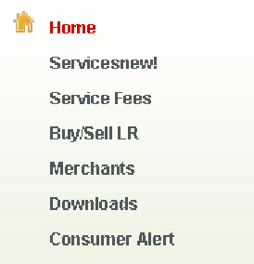

|  |  |  |  |  |
| --- | --- | --- | --- | --- |
| **USE CASE - <Frontend> Homepage – Top navigation** | | | | |
| **Use-case No.** | UC.F1.3 | **Use-case Version** | | 1.0 |
| **Use-case Name** | <Frontend> Main Navigation | | | |
| **Author** | AnhTT | | | |
| **Date** | 13/04/2012 | **Priority** | Normal | |
| **Actor:**  Every User  **Summary:**  As a user of IStockGold, I want to have the top navigation bar to navigate among the pages of the site.  **Goal:**  This Use Case is a sub Use Case of the Homepage. User will see an additional Navigation (display on the top of the page)  **Triggers**  N/A  **Preconditions:**  User enters the website.  **Post Conditions:**  N/A  **Main Success Scenario:**   |  |  |  | | --- | --- | --- | | Step | Actor Action | System Response | | 1 | User enter the website | Homepage is displayed, The Top navigation is display on the top of the page. Please refer to the screen for more detail version. |   **Alternative Scenario:**  N/A  **Exceptions:**  **Relationships:**  **Business Rules:**  The menu includes the following links:   * Tracking my Order * My Account * FAQ * About Us | | | | |

Screen:

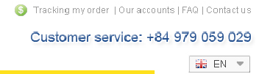

|  |  |  |  |  |
| --- | --- | --- | --- | --- |
| **USE CASE - <Frontend> Homepage – Live support** | | | | |
| **Use-case No.** | UC.F1.4 | **Use-case Version** | | 1.0 |
| **Use-case Name** | <Frontend> Live support | | | |
| **Author** | AnhTT | | | |
| **Date** | 13/04/2012 | **Priority** | Normal | |
| **Actor:**  Every User  **Summary:**  As a user, I want to see the information which I can use for LIVE Support.  **Goal:**  This Use Case is a sub Use Case of the Homepage. User will see a box on the left side which give information about the contact, which user can use for Live Supporting.  **Triggers**  N/A  **Preconditions:**  User enters the website.  **Post Conditions:**  N/A  **Main Success Scenario:**   |  |  |  | | --- | --- | --- | | Step | Actor Action | System Response | | 1 | User enter the website | Homepage is displayed, which include the “Live support” box on the left side of ther page. |   **Alternative Scenario:**  N/A  **Exceptions:**  **Relationships:**  **Business Rules:**  The LIVE SUPPORT should contain the following information;   * Yahoo online support 1 * Yahoo online support 2 * ICQ support   Each contact should have a status (online/offline). | | | | |

Screen:

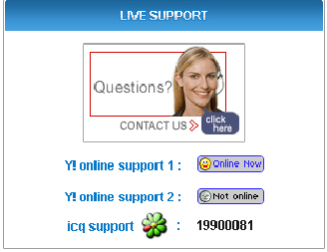

|  |  |  |  |  |
| --- | --- | --- | --- | --- |
| **USE CASE - <Frontend> Homepage – ISTOCKGOLD E-CURRENCY RESERVE** | | | | |
| **Use-case No.** | UC.F1.5 | **Use-case Version** | | 1.0 |
| **Use-case Name** | <Frontend> ISTOCKGOLD E-CURRENCY RESERVE | | | |
| **Author** | AnhTT | | | |
| **Date** | 13/04/2012 | **Priority** | Normal | |
| **Actor:**  Every User can view this information  **Summary**  As a User of IstockGold, I want to view the current status of the reserve account of the website owner for each payment method  **Goal:**  This box will give user information about the current status of the Website Owner reserve on each account (Liberty Reserve, Paypal, and Western Union)  **Triggers**  N/A  **Preconditions:**  User enters the website.  **Post Conditions:**  N/A  **Main Success Scenario:**   |  |  |  | | --- | --- | --- | | Step | Actor Action | System Response | | 1 | User enter the website | Homepage is displayed, which include the “ISTOCKGOLD E-CURRENCY RESERVE” box on the left side of ther page. The left side of the box display the name of the provider, the right side display the amount for each account. |   **Alternative Scenario:**  N/A  **Exceptions:**  **Relationships:**  Data for this box is taken from Database, where the data is set from Administration view. Please refer to Use Case <FIXME> for more detail  **Business Rules:** | | | | |

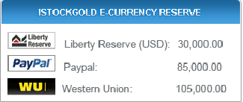

|  |  |  |  |  |
| --- | --- | --- | --- | --- |
| **USE CASE - <Frontend> Homepage – LATEST EXCHANGE** | | | | |
| **Use-case No.** | UC.F1.6 | **Use-case Version** | | 1.0 |
| **Use-case Name** | <Frontend> Latest Exchange | | | |
| **Author** | AnhTT | | | |
| **Date** | 13/04/2012 | **Priority** | Normal | |
| **Actor:**  Every User can view this information  **Summary**  This box will give user information about the top 5 recent transactions from the site.  **Goal:**  Display the top 5 recent transactions occur in the website with summary information.  **Triggers**  N/A  **Preconditions:**  User enters the website.  **Post Conditions:**  N/A  **Main Success Scenario:**   |  |  |  | | --- | --- | --- | | Step | Actor Action | System Response | | 1 | User enter the website | Homepage is displayed, which include the “LATEST EXCHANGE” box on the left side of the page. This box is a table which has for Column: Date, Action, User, and Amount. |   **Alternative Scenario:**  N/A  **Exceptions:**  **Relationships:**  **Business Rules:**  The top 5 latest success transaction will be taken from the Database and display | | | | |

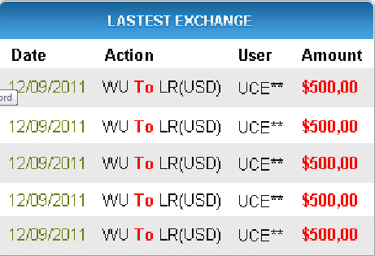

|  |  |  |  |  |
| --- | --- | --- | --- | --- |
| **USE CASE - <Frontend> Homepage – The main content (Exchange the money)** | | | | |
| **Use-case No.** | UC.F1.7 | **Use-case Version** | | 1.0 |
| **Use-case Name** | <Frontend> The main content | | | |
| **Author** | AnhTT | | | |
| **Date** | 13/04/2012 | **Priority** | Normal | |
| **Actor:**  Every User can view this information  **Summary**  As a user I want to view the main content of the hompage  **Goal:**  Display the main content and basic functions of the site.  **Triggers**  N/A  **Preconditions:**  User enters the website.  **Post Conditions:**  N/A  **Main Success Scenario:**   |  |  |  | | --- | --- | --- | | Step | Actor Action | System Response | | 1 | User enter the website | Homepage is displayed, which include the left side bar, and the main contain display at the center of the page. The main content displayed the basic function of the page: Exchange the money between different accounts. |   **Alternative Scenario:**  N/A  **Exceptions:**  **Relationships:**  To exchange the money, please refer to use case <FIXME> for more detail.  **Business Rules:**  The Box have 1 tabs, the first tab is active when user enter the home page. The box includes the following information:   * What’s your currency base? The account from which money is transferred * What’s currency you will get? The account to which money is transferred * Rate: the rate to exchange between the two * Exchange button: to do the Exchange function   The site currently supports to exchange between two accounts of Liberty Reserve and Western Union and vice versa.   * Exchange-out Currency must be different with Exchange-in Currency, back to change   When you change the account to exchange, the rate is change instantly, without Page refreshing. | | | | |

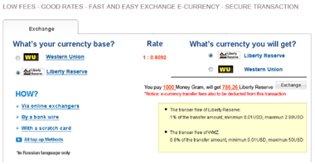

|  |  |  |  |  |
| --- | --- | --- | --- | --- |
| **USE CASE - <Frontend> Homepage – News** | | | | |
| **Use-case No.** | UC.F1.8 | **Use-case Version** | | 1.0 |
| **Use-case Name** | <Frontend> News | | | |
| **Author** | AnhTT | | | |
| **Date** | 13/04/2012 | **Priority** | Normal | |
| **Actor:**  Every User can view this information  **Summary**  As a user I want to view the News in the home page  **Goal:**  Display the latest news, which is updated by the administrator  **Triggers**  N/A  **Preconditions:**  User enters the website.  **Post Conditions:**  N/A  **Main Success Scenario:**   |  |  |  | | --- | --- | --- | | Step | Actor Action | System Response | | 1 | User enter the website | Homepage is displayed, which include the left side bar, and the main content, The News box is displayed under the main content. The top 5 links to the latest news will be displayed. There is a link to let user view the “News” page – which display all the News |   **Alternative Scenario:**  N/A  **Exceptions:**  **Relationships:**  To upload news, refer to use case <FIXME> for more detail.  **Business Rules:**  Top 5 news will be displayed in the box | | | | |



|  |  |  |  |  |
| --- | --- | --- | --- | --- |
| **USE CASE - <Frontend> Homepage – Feedback** | | | | |
| **Use-case No.** | UC.F1.9 | **Use-case Version** | | 1.0 |
| **Use-case Name** | <Frontend> Review - Feedback | | | |
| **Author** | AnhTT | | | |
| **Date** | 13/04/2012 | **Priority** | Normal | |
| **Actor:**  Every User can view this information  **Summary**  As a user I want to view the reviews/feedbacks of other user.  **Goal:**  Display the reviews/feedbacks of user.  **Triggers**  N/A  **Preconditions:**  User enters the website.  **Post Conditions:**  N/A  **Main Success Scenario:**   |  |  |  | | --- | --- | --- | | Step | Actor Action | System Response | | 1 | User enter the website | Homepage is displayed. Reviews feeds will be displayed below the “News” box. There will be an option for the user to change how much reviews they want to display. Paging information also be display here | | 2 | User change the “Show” box to different number | Paging information also change, the page is not refresh |   **Alternative Scenario:**  N/A  **Exceptions:**  **Relationships:**  To write a review, refer to use case UC.F1.10 for more detail.  **Business Rules:**  A review should include the following parts:   * Rating (display as star, 5 stars is the maximum) * The name of user * Location of the user * The review content * The date that the review is written   Paging information should include the “First”, “Previous”, “Next”, and “Last” links for easy navigation. | | | | |

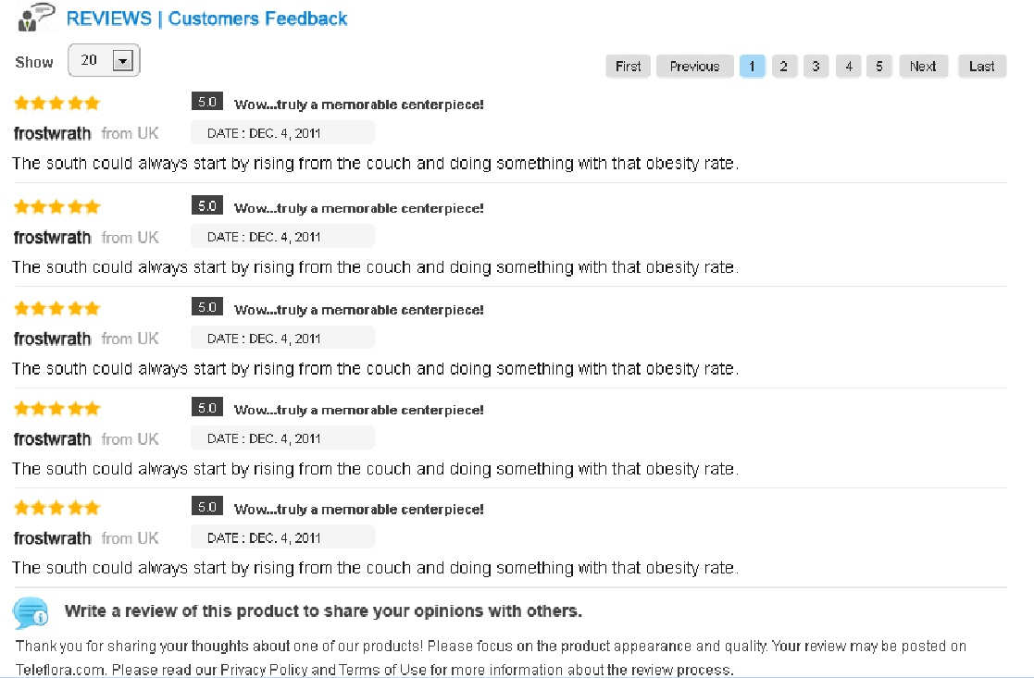

|  |  |  |  |  |
| --- | --- | --- | --- | --- |
| **USE CASE - <Frontend> Homepage –** Write review/feedback | | | | |
| **Use-case No.** | UC.F1.10 | **Use-case Version** | | 1.0 |
| **Use-case Name** | <Frontend> Write review/feedback | | | |
| **Author** | AnhTT | | | |
| **Date** | 13/04/2012 | **Priority** | Normal | |
| **Actor:**  Every User  **Summary**  As a user I want to write my own feedback.  **Goal:**  **Triggers**  N/A  **Preconditions:**  User enters the website. Homepage is displayed  **Post Conditions:**  N/A  **Main Success Scenario:**   |  |  |  | | --- | --- | --- | | Step | Actor Action | System Response | | 1 | User enter the website | Homepage is displayed. | | 2 | User enter required information for writing a review. | The new reviews will be append to the “reviews box” without the page refresh. |   **Alternative Scenario:**  N/A  **Exceptions:**  **-** If user missing mandatory information, error message will occurs.  **Relationships:**  **Business Rules:**  The following information are mandatory:   * Name : your name * Location: your location. Location will display as a dropbox, user can choose for their location. <Which locations to be displayed have to be define by Mr Quyen) * Email: your email * Order Number: The review function only makes sense for the user has used the exchange function. You have to enter a correct OrderId in order to write the review. * Review Title: the title of the review (Which will be display in the review box) * Comment: Detail comment of the reviews. * The Rating: How many stars you would rate for our service? | | | | |

### Exchange from Liberty Reserve to Western Union

#### Use Case Diagram



#### Use Case Specification

|  |  |  |  |  |
| --- | --- | --- | --- | --- |
| **USE CASE - <Frontend> Exchange Money from “Liberty Reserve” to “Western Union”** | | | | |
| **Use-case No.** | UC.F2 | **Use-case Version** | | 1.0 |
| **Use-case Name** | <Frontend> Exchange Money from “Liberty Reserve” to “Western Union” | | | |
| **Author** | AnhTT | | | |
| **Date** | 13/04/2012 | **Priority** | Normal | |
| **Actor:**  Every User  **Summary**  As a user I Exchange the money from Liberty Reserve account to Western Union account.  **Goal:**  Exchange the money from Liberty to Western Union  **Triggers**  N/A  **Preconditions:**  **Post Conditions:**  N/A  **Main Success Scenario:**   |  |  |  | | --- | --- | --- | | Step | Actor Action | System Response | | 1 | User enter the website | Homepage is displayed. | | 2 | User choose “Liberty reserve” for Exchange Out currency, Western Union for Exchange In currency | The rate is change correspondingly | | 3 | User enter the amount they want to transfer, and click submit | Redirect to the page where user can enter detail information for the transaction. Summary of the transaction is display on top. | | 4 | User enter correct information | Redirect to “Liberty” page | | 5 | User enter their credential for the account at Liberty | Login success, Redirect to “confirmation” page | | 6 | User confirm the payment | Transaction is success, redirect back to “Merchant” page, which is our page. User will get back the OrderId |   **Alternative Scenario:**  N/A  **Exceptions:**  **-** If user missing mandatory information, error message will occurs.  **Relationships:**  **Business Rules:**  The following information are mandatory for a transaction to exchange from Liberty to WU   * Receiver’s First Name * Receiver’s Last Name * Receiver’s Street * Receiver’s City * Receiver’s state/province * Receiver’s Country * Receiver’s postal code * Your Email * Captcha   Notices will be display at this page:   * Notice1: you will get paid in 24 hours and you pay the Western Union fee * Notice 2: the min amount is 300USD for a Western Union transfer | | | | |

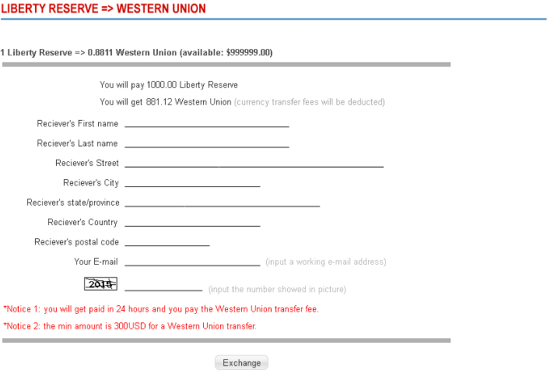

### Exchange from Western Union to Liberty Reserve

#### Use Case Diagram



#### User Case Specification

|  |  |  |  |  |
| --- | --- | --- | --- | --- |
| **USE CASE - <Frontend> Exchange Money from “Western Union” to “Liberty Reserve”** | | | | |
| **Use-case No.** | UC.F3 | **Use-case Version** | | 1.0 |
| **Use-case Name** | <Frontend> Exchange Money from “Western Union “ to “Liberty Reserve” | | | |
| **Author** | TungNS | | | |
| **Date** | 13/04/2012 | **Priority** | Normal | |
| **Actor:**  Every User  **Summary**  As a user I Exchange the money from Western Union account to Liberty Reserve account  **Goal:**  Exchange the money from Western Union to Liberty Reserve  **Triggers**  N/A  **Preconditions:**  **Post Conditions:**  N/A  **Main Success Scenario:**   |  |  |  | | --- | --- | --- | | Step | Actor Action | System Response | | 1 | User enter the website | Homepage is displayed. | | 2 | User choose “Western Union” for Exchange Out currency, “Liberty Reserve” for Exchange In currency | The rate is change correspondingly | | 3 | User enter the amount they want to transfer, and click submit | Redirect to the page where user can see the details step to exchange from “Western Union” to “Liberty Reserve”. | | 4 | User follows the step, go to the bank to deposit money to account, which is owned by the page owner. After that user can get Money Tranfer Control Number of Western Union Transaction |  | | 5 | User fill the Money Tranfer Control Number and needed information in form |  | | 6 | User confirm the payment | Transaction is recorded and wait to page owner confirm.  Redirect back to “Merchant” page, which is our page. User will get back the OrderId. |   **Alternative Scenario:**  N/A  **Exceptions:**  **-** If user missing mandatory information, error message will occurs.  **Relationships:**  **Business Rules:**  The following information are mandatory for a transaction to exchange from Westtern Union to Liberty Reserve   * MTCN * Sender’s First Name * Sender’s Last Name * Sender’s City * Sender’s Country * Receiver’s postal code * Your LR Account * Your Email * Captcha   Notices will be display at this page:   * Notice1: you will get paid in 24 hours and you pay the Western Union fee | | | | |

Screen:

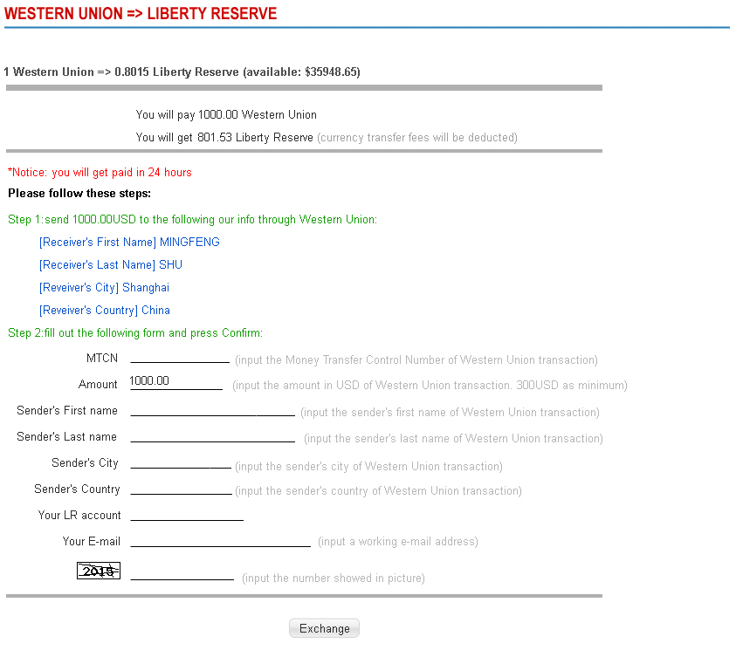

### Service fee

#### Use Case Diagram



#### Use case specification

|  |  |  |  |  |
| --- | --- | --- | --- | --- |
| **USE CASE - <Frontend> Service fee** | | | | |
| **Use-case No.** | UC.F4 | **Use-case Version** | | 1.0 |
| **Use-case Name** | <Frontend> Service Fee | | | |
| **Author** | TungNS | | | |
| **Date** | 13/04/2012 | **Priority** | Normal | |
| **Actor:**  Every User  **Summary**  Display the service fee to user  **Goal:**  User can see the service fee of the website  **Triggers**  N/A  **Preconditions:**  **Post Conditions:**  N/A  **Main Success Scenario:**   |  |  |  | | --- | --- | --- | | Step | Actor Action | System Response | | 1 | User enter the website | Homepage is displayed. | | 2 | User “Service Fee” on top navigation | Service fee page is displayed |   **Alternative Scenario:**  N/A  **Exceptions:**  N/A  **Relationships:**  The content of this page is manageable in the Administration view. Please see UseCase “FIXME” for detail.  **Business Rules:** | | | | |

Screen:

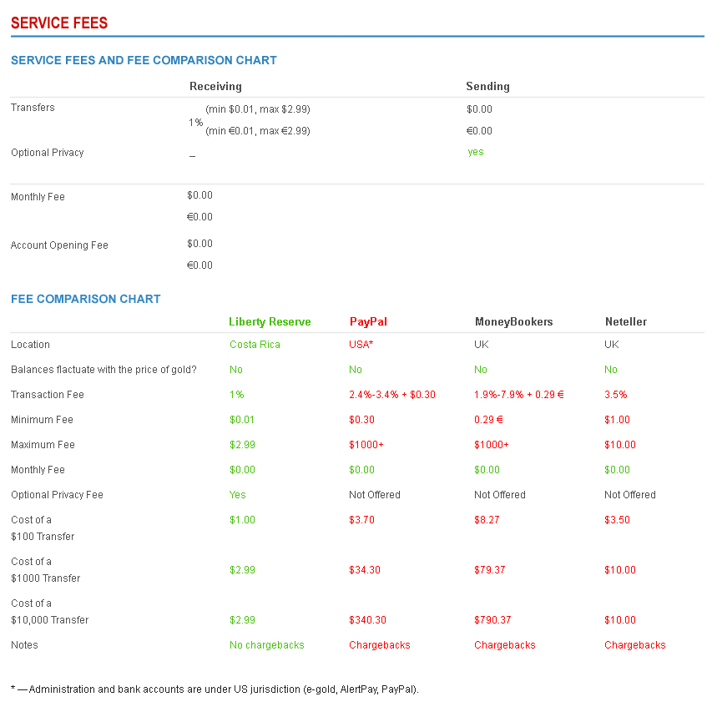

### Service news

#### Use Case Diagram



#### Use case specification:

|  |  |  |  |  |
| --- | --- | --- | --- | --- |
| **USE CASE - <Frontend> Service news** | | | | |
| **Use-case No.** | UC.F5 | **Use-case Version** | | 1.0 |
| **Use-case Name** | <Frontend> Service News | | | |
| **Author** | TungNS | | | |
| **Date** | 13/04/2012 | **Priority** | Normal | |
| **Actor:**  Every User  **Summary**  Display the service news to user  **Goal:**  User can see the service news of the website  **Triggers**  N/A  **Preconditions:**  **Post Conditions:**  N/A  **Main Success Scenario:**   |  |  |  | | --- | --- | --- | | Step | Actor Action | System Response | | 1 | User enter the website | Homepage is displayed. | | 2 | User “Service News” on top navigation | Service news page is displayed |   **Alternative Scenario:**  N/A  **Exceptions:**  N/A  **Relationships:**  The content of this page is manageable in the Administration view. Please see UseCase “FIXME” for detail.  **Business Rules:** | | | | |

### Order tracking

#### Use Case Diagram



#### Use case specification:

|  |  |  |  |  |
| --- | --- | --- | --- | --- |
| **USE CASE - <Frontend> Order tracking** | | | | |
| **Use-case No.** | UC.F6 | **Use-case Version** | | 1.0 |
| **Use-case Name** | <Frontend> Order tracking | | | |
| **Author** | AnhTT | | | |
| **Date** | 13/04/2012 | **Priority** | Normal | |
| **Actor:**  Every User who has place an order and receive the order code.  **Summary:**  As a user I want to track the status of orders I have placed.  **Goal:**  View summary information of the order that is founded.  **Triggers**  N/A  **Preconditions:**  User enter the website, and place an order.  **Post Conditions:**  N/A  **Main Success Scenario:**   |  |  |  | | --- | --- | --- | | Step | Actor Action | System Response | | 1 | User click on the “Tracking my order” link at the top navigation of the Home page | Redirect to the page where user can enter the OrderID, order Amount and Catpcha | | 2 | User enters required information | Redirect to the page which display the summary of the order. |   **Alternative Scenario:**  N/A  **Exceptions:**   * If user enter OrderId that is not exist 🡪 Error message “Order Not Found”, and a Back button to return to the “Enter Order Id” page * If user enter wrong Captcha 🡪 Error message “Wrong validation code” , and a Back button to return to the “Enter Order Id” Page   **Relationships:**  N/A  **Business Rules:**  Mandatory fields are:   * Name * Email Address * Content | | | | |

Screen:

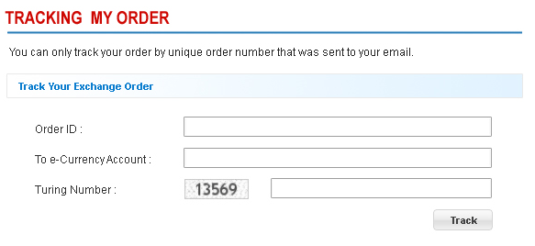

### Contact us

#### Use Case Diagram



#### Use case specification:

|  |  |  |  |  |
| --- | --- | --- | --- | --- |
| **USE CASE - <Frontend> Contact us** | | | | |
| **Use-case No.** | UC.F7 | **Use-case Version** | | 1.0 |
| **Use-case Name** | <Frontend> Contact us | | | |
| **Author** | AnhTT | | | |
| **Date** | 13/04/2012 | **Priority** | Normal | |
| **Actor:**  Every User  **Summary:**  This use case help user to give there feedbacks, question to the administration of the website.  **Goal:**  Allows the admin to view specific currency infor & password of this currency  **Triggers**  N/A  **Preconditions:**  User enter the website, and click to “Contact Us”  **Post Conditions:**  N/A  **Main Success Scenario:**   |  |  |  | | --- | --- | --- | | Step | Actor Action | System Response | | 1 | User click on the “Contact us” link at the main navigation of the Home page | Redirect to the “Contact us” page. Where user can see the map where the company located | | 2 | User enter information to the form. Fill the Captcha. And click submit. | System will validate the information user has entered. |   **Alternative Scenario:**  N/A  **Exceptions:**   * Error will occurs if user enter the wrong Captcha, the page is refresh but should keep the information user has entered * If user do not fill enough mandatory fields, then Error Message should indicate what’s missing. So the user is easy to correct what is going wrong.   **Relationships:**   * The Position of company in the map is taken from Database * The position is set in the admin view.   **Business Rules:**  Mandatory fields are:   * Name * Email Address * Content | | | | |

Screen:

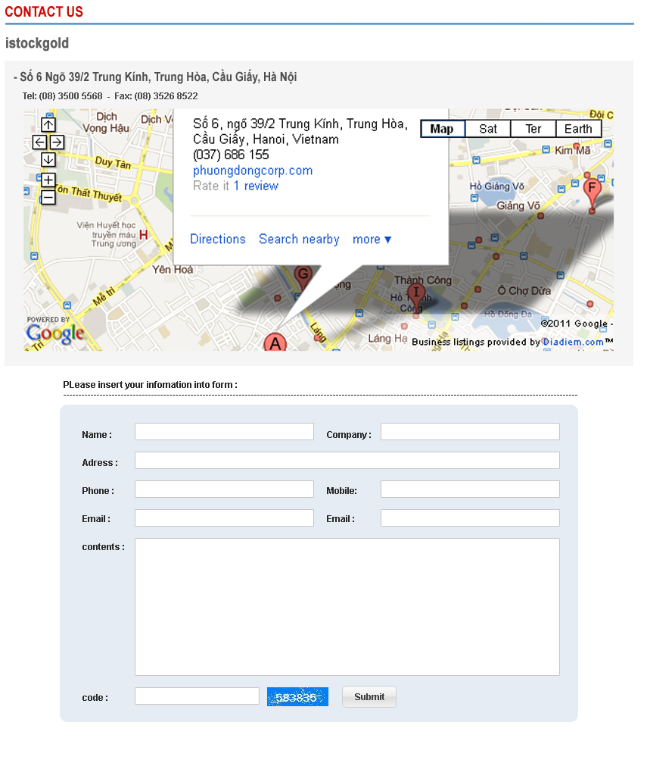

### FAQ

#### Use Case Diagram



#### Use case specification:

|  |  |  |  |  |
| --- | --- | --- | --- | --- |
| **USE CASE - <Frontend> Frequently Asked Questions** | | | | |
| **Use-case No.** | UC.F9 | **Use-case Version** | | 1.0 |
| **Use-case Name** | <Frontend> Frequently Asked Questions | | | |
| **Author** | AnhTT | | | |
| **Date** | 13/04/2012 | **Priority** | Normal | |
| **Actor:**  Every User.  **Summary:**  Some user got troubles when using this website. This is where you can give help to people, by answering the most frequently asked questions.  **Goal:**  The page should display the content in the format of “Question” and “Answer”. To let the user can have an answer for their problems.  **Triggers**  N/A  **Preconditions:**  User enter the website, and click to “About us”  **Post Conditions:**  N/A  **Main Success Scenario:**   |  |  |  | | --- | --- | --- | | Step | Actor Action | System Response | | 1 | User click on the “FAQ” link at the main navigation of the Home page | Redirect to the “FAQ” page. This page display content in the format of “Question” and “Answer”. The Question is in blue <Please see the screen session>, and the answer is in the normal font (black text) below the question. |   **Alternative Scenario:**  N/A  **Exceptions:**  N/A  **Relationships:**  The content of this page is manageable in the Administration view. Please see UseCase “FIXME” for detail.  **Business Rules:** | | | | |

Screen:

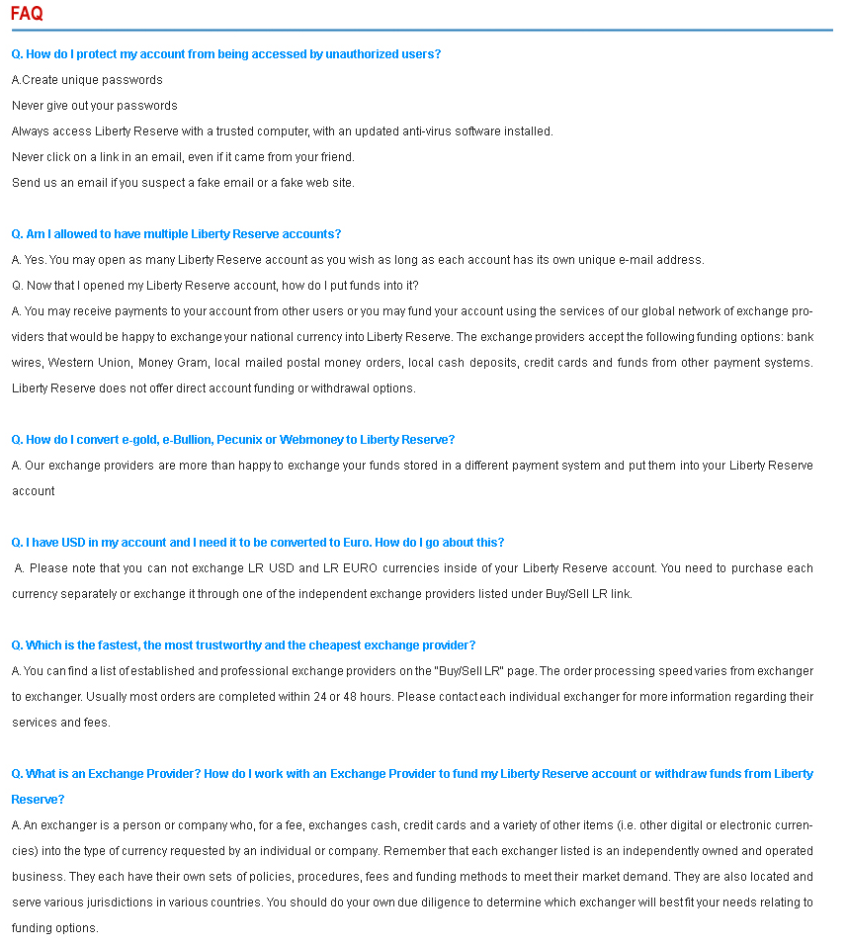

### About

#### Use Case Diagram



#### Use case specification:

|  |  |  |  |  |
| --- | --- | --- | --- | --- |
| **USE CASE - <Frontend> About** | | | | |
| **Use-case No.** | UC.F9 | **Use-case Version** | | 1.0 |
| **Use-case Name** | <Frontend> About | | | |
| **Author** | AnhTT | | | |
| **Date** | 13/04/2012 | **Priority** | Normal | |
| **Actor:**  Every User.  **Summary:**  User can view the detail information of the company  **Goal:**  What you want the user to know, give it to the user.  **Triggers**  N/A  **Preconditions:**  User enter the website, and click to “About us”  **Post Conditions:**  N/A  **Main Success Scenario:**   |  |  |  | | --- | --- | --- | | Step | Actor Action | System Response | | 1 | User click on the “About us” link at the main navigation of the Home page | Redirect to the “About us” page. The content of this page is taken from the DB. In the administrative view, there is a place where you can edit the information to display in this page. |   **Alternative Scenario:**  N/A  **Exceptions:**  N/A  **Relationships:**  **Business Rules:** | | | | |

Screen:

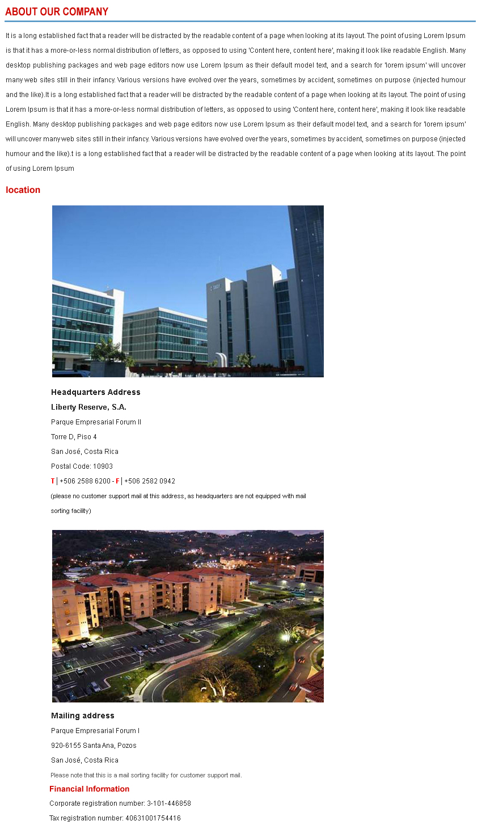

### <Admin>View admin home page

#### Use Case Diagram



#### *Use Case Specification*

|  |  |  |  |  |
| --- | --- | --- | --- | --- |
| **USE CASE - View admin home page SPECIFICATION** | | | | |
| **Use-case No.** | UC.A001 | **Use-case Version** | | 1.0 |
| **Use-case Name** | View admin home page | | | |
| **Author** | HoaHM | | | |
| **Date** | 13/04/2012 | **Priority** | Normal | |
| **Actor:**  Admin  **Summary:**  After login into the website with admin role, system will redirect user to admin home page with full control and listing all of features that system has supported.This use-case also provide some statistic information and overview of backend.  **Goal:**  Allow admin to view all features for controlling system and some basic information  **Triggers**  Click on the MenuItem “Admin Home” or first time load.  **Preconditions:**  User logged into the system with admin role successfully.  **Post Conditions:**  System redirects user to the admin home page.  **Main Success Scenario:**   |  |  |  | | --- | --- | --- | | Step | Actor Action | System Response | | 1 | Login with role admin successfully | Redirect to Admin Home Page  Show all features and information |   **Relationships:**  Log in use case  **Business Rules:**  The same functions will be in same group on menu.  In the main part of home page, the page is devided into many parts.Every part will have some same functions. Every function has a small description below. | | | | |

**Screen**

**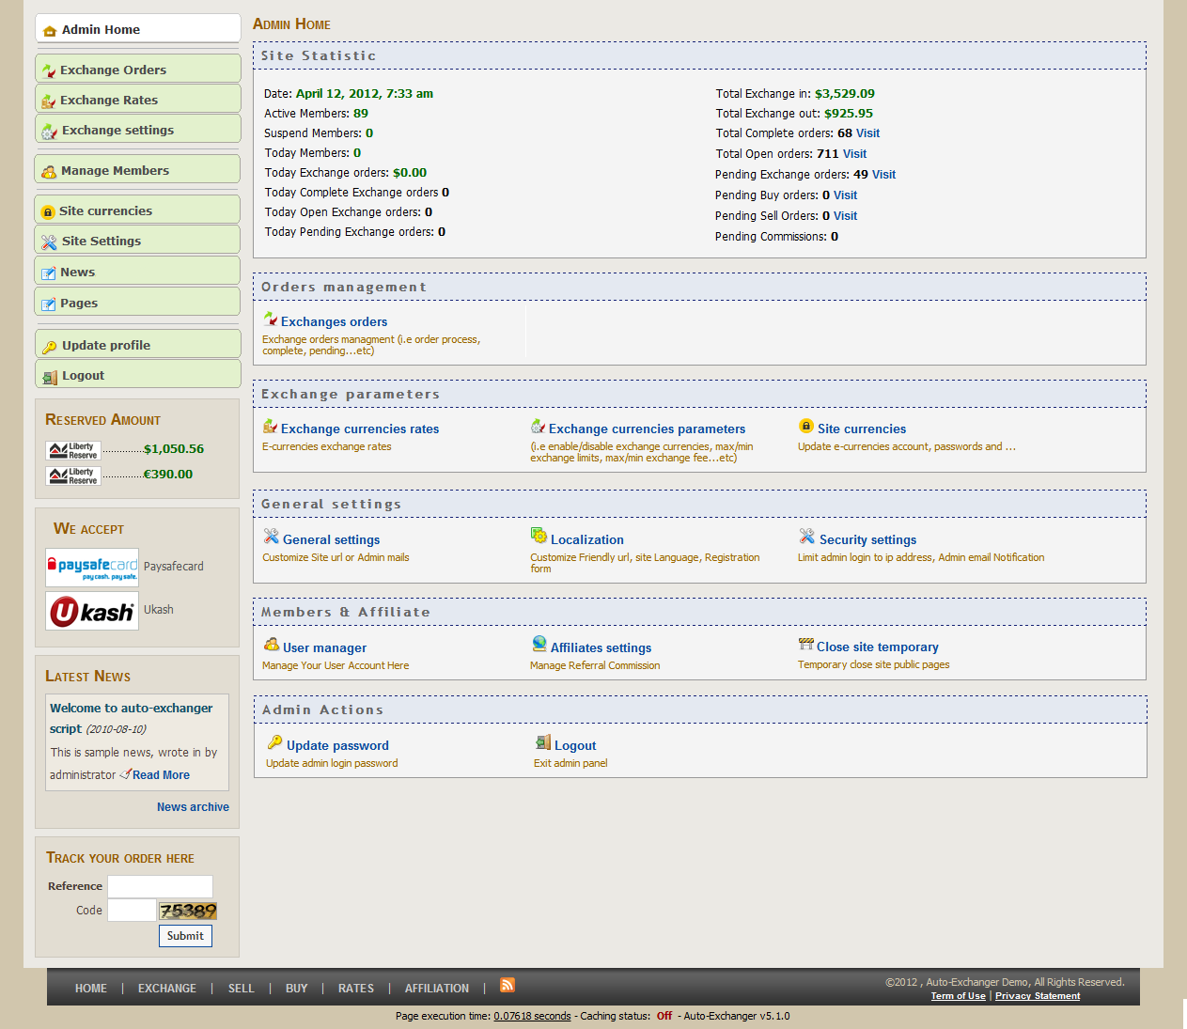**

**Buttons / Hyper Links – Attach Place Page**

|  |  |  |  |  |
| --- | --- | --- | --- | --- |
| **Function** | **Description** | **Available Criteria** | **Validations** | **Outcome** |
| Exchange orders | This hyper will redirect user to Order management | Always available | No validations | Refer to Exchange Order Page |
| Exchange currencies rates | This hyper will redirect user to Exchanges Rates with updating rates function | Always available | No validations | Refer to Exchange Rates Page |
| Exchange ocurrencies parameter | This hyper will redirect user to Exchanges Settings with update all currencies and add new currency | Always available | No validations | Refer to Exchange Settings Page |
| Sites currencies rates | This hyper will redirect user to page that enable and configure the e-currencies admin wants to accept in | Always available | No validations | Refer to Manage Currencies info & passwords Page |
| General setting | This hyperlink will redirect user to page with tab Gerenal and admin can change the site url, site name… | Always available | No validations | Refer to Site Settings Page |
| Localization | This hyperlink will redirect user to page with tab Localization and admin can change language… | Always available | No validations | Refer to Site Settings Page |
| Security setting | This hyperlink will redirect user to page with tab Security and admin can change the login ip… | Always available | No validations | Refer to Site Settings Page |
| User manager | This hyperlink will redirect user to page and admin can view all user, view details of users… | Always available | No validations | Refer to Members management Page |
| Affiliates settings | This hyperlink will redirect user to page to Manage Referral Commission | Always available | No validations | Refer to Site Settings Page |
| Close site temporary | This hyperlink will redirect user to page to Temporary close site public pages | Always available | No validations | Refer to Site Settings Page |
| Update password | This hyperlink will redirect user to page to change her/his password | Always available | No validations | Refer to Update Profile |
| Log out | This hyperlink will allow for user log out from system | Always available | No validations | Refer to Home Page (default page without login) |

### <Admin>View Open Order

#### Use Case Diagram



#### Use Case Specification

|  |  |  |  |  |
| --- | --- | --- | --- | --- |
| **USE CASE- View Open Order SPECIFICATION** | | | | |
| **Use-case No.** | UC.A002 | **Use-case Version** | | 1.0 |
| **Use-case Name** | View Open Order | | | |
| **Author** | HoaHM | | | |
| **Date** | 13/04/2012 | **Priority** | Normal | |
| **Actor:**  Admin  **Summary:**  When the admin want system to show all the open order in the list.The list of order will be shown and the total number of orders will displayed in the bottom of list  **Goal:**  This use case allows admin view all of information of open order  **Triggers**  Click on the “Exchanges Orders” menu item or “Exchanges Orders” hyperlink  **Preconditions:**  Logged into the system successfully and open the admin home pages.  **Post Conditions:**  Redirected to Exchange orders Pending page  **Main Success Scenario:**   |  |  |  | | --- | --- | --- | | Step | Actor Action | System Response | | 1 | Admin click on the “Exchanges Orders” menu item | System displays Exchange Order Pending |   **Alternative Scenario:**   |  |  |  | | --- | --- | --- | | Step | Actor Action | System Response | | 1 | Admin click on the “Exchanges Orders” hyperlink | System displays Exchange Order Pending |     **Relationships:**  Log in use case, View admin home page use case  **Business Rules:**   |  |  |  | | --- | --- | --- | |  | Business Rule | Error Message | | 1 | Display only the the order with have status “Open” |  | | 2 | In the case there’s no have “Open Orders” | No Open Orders found. | | | | | |

**Screen**

**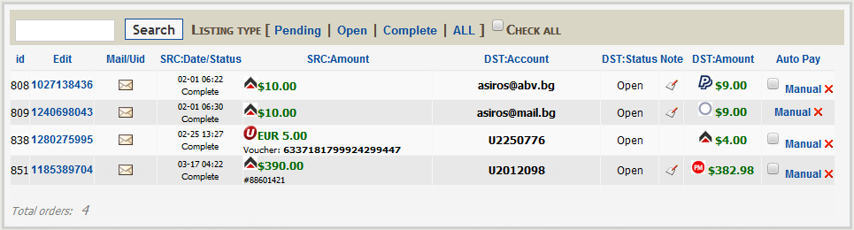**

### <Admin>Search Order

#### Use Case Diagram



#### Use Case Specification

|  |  |  |  |  |
| --- | --- | --- | --- | --- |
| **USE CASE- Search Order SPECIFICATION** | | | | |
| **Use-case No.** | UC.A003 | **Use-case Version** | | 1.0 |
| **Use-case Name** | Search Order | | | |
| **Author** | HoaHM | | | |
| **Date** | 13/04/2012 | **Priority** | Normal | |
| **Actor:**  Admin  **Summary:**  When the information becomes very large and the admin cannot see exactly some orders.So the search function will help the admin narrow the result and return the result with inputted conditions.  **Goal:**  This use case allows the admin find out the result that he/she expected  **Triggers**  Click on the “Search” button  **Preconditions:**  Logged into the system successfully and open Exchange Order Pending page  **Post Conditions:**  Exchange Order page with results will be shown with the conditions that admin inputted  **Main Success Scenario:**   |  |  |  | | --- | --- | --- | | Step | Actor Action | System Response | | 1 | Input into the the textbox the search condition |  | | 2 | Click on to “Search” button | The page will be refreshed and search result will be shown. |   **Alternative Scenario:**   |  |  |  | | --- | --- | --- | | Step | Actor Action | System Response | | 1 | Input into the the textbox the search condition |  | | 2 | Press Enter key | The page will be refreshed and search result will be shown. |   **Exceptions:**  None  **Relationships:**  Log in use case, View Open Order  **Business Rules:**   |  |  |  | | --- | --- | --- | |  | Business Rule | Error Message | | 1 | The search result will be shown with exactly according to inputted condition |  | | 2 | In the case these has no result with inputted conditions | Only show the header of grid and message error is “There is not any Order” | | 3 | Input nothing into search textbox and click “Search” button | Show all the results | | | | | |

**Screen**

****

**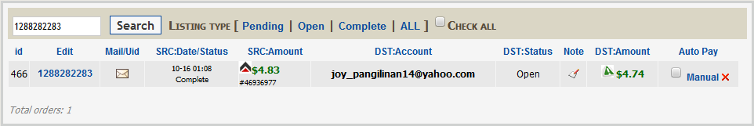**

**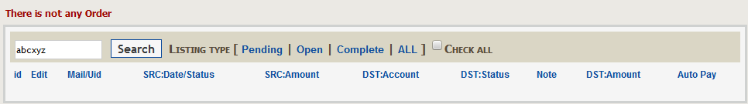**

### <Admin>Filter Order (Listing type)

#### Use Case Diagram



#### Use Case Specification

|  |  |  |  |  |
| --- | --- | --- | --- | --- |
| **USE CASE- Filter Order (Listing type)SPECIFICATION** | | | | |
| **Use-case No.** | UC.A004 | **Use-case Version** | | 1.0 |
| **Use-case Name** | Filter Order (Listing type) | | | |
| **Author** | HoaHM | | | |
| **Date** | 13/04/2012 | **Priority** | Normal | |
| **Actor:**  User  **Summary:**  This use case allows the admin narrow the list of Order  **Goal:**  Display the narrowed list of Order.  **Triggers**  Click on the button that displays the type of status  **Preconditions:**  User is in the Exchange Order Page  **Post Conditions:**  Display the search result in Exchange Order Page  **Main Success Scenario:**   |  |  |  | | --- | --- | --- | | Step | Actor Action | System Response | | 1 | Click on type of status | System displays the search result based on the clicked status |   **Exceptions:**  None  **Relationships:**  View Open Order  **Business Rules:**   |  |  |  | | --- | --- | --- | |  | Business Rule | Error Message | | 1 | Click on one of Status | The result will be shown based on the inputted status | | 2 | Click on “ALL” status | System will display all results. | | | | | |

**Screen**

****

**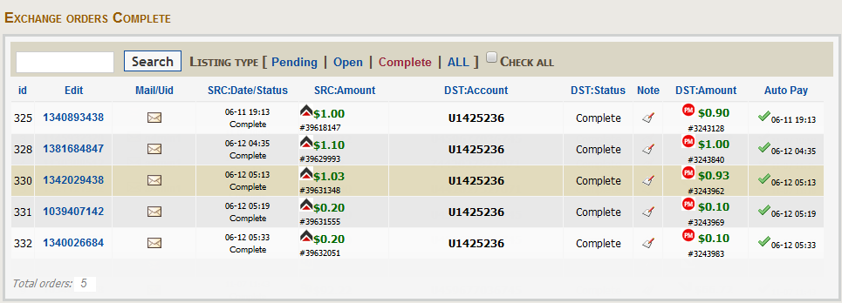**

### <Admin>Delete Order

#### Use Case Diagram



#### Use Case Specification

|  |  |  |  |  |
| --- | --- | --- | --- | --- |
| **USE CASE- Delete Order SPECIFICATION** | | | | |
| **Use-case No.** | UC.A005 | **Use-case Version** | | 1.0 |
| **Use-case Name** | Delete Order | | | |
| **Author** | HoaHM | | | |
| **Date** | 13/04/2012 | **Priority** | Normal | |
| **Actor:**  User  **Summary:**  This use case allows the actor delete one order  **Goal:**  Delete one orderfrom system  **Triggers**  Click on the “X” button on the grid  **Preconditions:**  Display the grid to admin  **Post Conditions:**  The deleted order will be removed in the grid  **Main Success Scenario:**   |  |  |  | | --- | --- | --- | | Step | Actor Action | System Response | | 1 | Click on the “X” button of one record in the grid | The confirm popup message will be displayed. | | 2 | Click Yes button of confirmation box | The Exchange Order will refresh and deleted record won’t be shown anymore. |   **Alternative Scenario:**   |  |  |  | | --- | --- | --- | | Step | Actor Action | System Response | | 1 | Click on the “X” button of one record in the grid | The confirm popup message will be displayed. | | 2 | Click No button of confirmation box | Nothing happens |   **Exceptions:**  In this case the order was be deleted by another user or system can not find this order.The error message will be shown to alert.  **Relationships:**  Log in use case, View Order  **Business Rules:**   |  |  |  | | --- | --- | --- | |  | Business Rule | Error Message | | 1 | Click on the “X” button of one record in the grid.After that, click on “Yes” button | The specified order will be deleted | | | | | |

**Screen**

**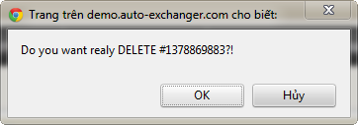**

****

****

### <Admin>Edit Order

#### Use Case Diagram



#### Use Case Specification

|  |  |  |  |  |
| --- | --- | --- | --- | --- |
| **USE CASE- Edit Order SPECIFICATION** | | | | |
| **Use-case No.** | UC.A006 | **Use-case Version** | | 1.0 |
| **Use-case Name** | Edit Order | | | |
| **Author** | HoaHM | | | |
| **Date** | 13/04/2012 | **Priority** | Normal | |
| **Actor:**  Admin  **Summary:**  This use case allows admin edit and updates some information of order.  **Goal:**  Edit and updates some information of order  **Triggers**  Click on the “Update” button on Edit Exchange Order page  **Preconditions:**  User is in the Edit Exchange Order page  **Post Conditions:**  Exchange Order page and message is displayed  **Main Success Scenario:**   |  |  |  | | --- | --- | --- | | Step | Actor Action | System Response | | 1 | Click on the Order ID or Note of Order in grid | System redirects admin to Edit Exchange Order page | | 2 | Change some information of Order |  | | 3 | Click on button “Update” | The information of Order will be changed and the Exchange Order will refresh. |   **Alternative Scenario:**   |  |  |  | | --- | --- | --- | | Step | Actor Action | System Response | | 1 | Click on the Order ID or Note of Order in grid | System redirects admin to Edit Exchange Order page | | 2 | Change some information of Order |  | | 3 | Click on button “Cancel” | The information of Order won’t be changed and the Exchange Order will refresh. |   **Exceptions:**  Error message will shown if update was interrupted or had some problems.  **Relationships:**  Log in use case, View Order  **Business Rules:**   |  |  |  | | --- | --- | --- | |  | Business Rule | Error Message | | 1 | Only the specified order will be updated with changed information |  | | 2 | In the case update specified order successfully | Display message: “Exchange order updated successfully” | | 3 | In the case deleted specified order failed | Display message: “Exchange order updated failed” | | | | | |

**Screen**

**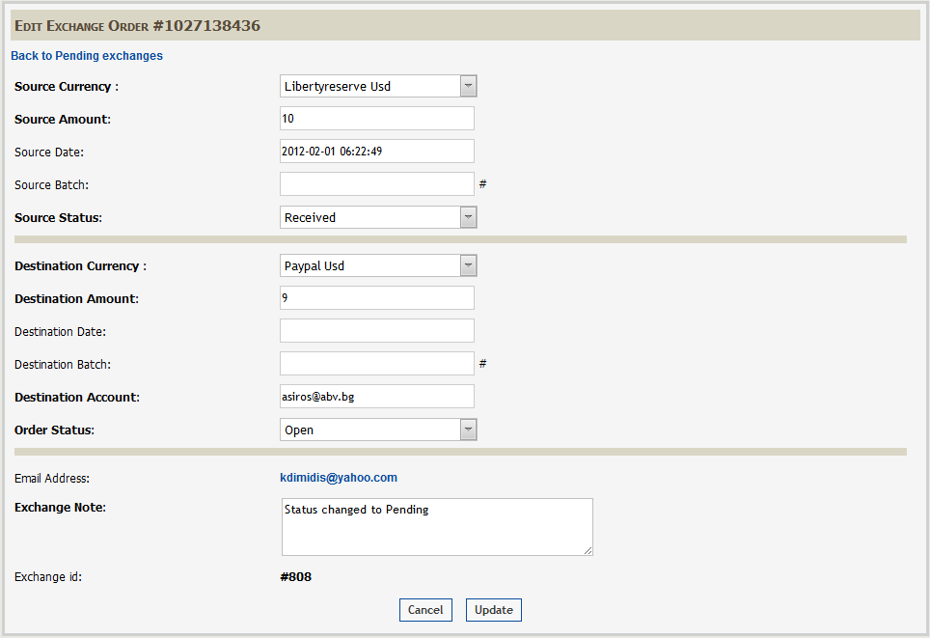**

****

### <Admin>Manually Pay Out

#### Use Case Diagram



#### Use Case Specification

|  |  |  |  |  |
| --- | --- | --- | --- | --- |
| **USE CASE- Manually Pay Out SPECIFICATION** | | | | |
| **Use-case No.** | UC.A007 | **Use-case Version** | | 1.0 |
| **Use-case Name** | Manually Pay Out | | | |
| **Author** | HoaHM | | | |
| **Date** | 13/04/2012 | **Priority** | Normal | |
| **Actor:**  Admin  **Summary:**  When admin to pay out manually with specified order  **Goal:**  Pay out manually  **Triggers**  Click on “Manual” hyperlink on the grid  **Preconditions:**  Logged into the system successful and open Exchange Order  **Post Conditions:**  Exchange Order will be refreshed.  **Main Success Scenario:**   |  |  |  | | --- | --- | --- | | Step | Actor Action | System Response | | 1 | Click to “Manual” hyperlink | Show the popup message | | 2 | Click on “Yes” button of popup message | Redirect to the appropriate page to execute pay out manually |  |  |  |  | | --- | --- | --- | | Step | Actor Action | System Response | | 1 | Click to “Manual” hyperlink | Show the popup message | | 2 | Click on “No” button of popup message | Nothing happens |   **Exceptions:**  None  **Relationships:**  Log in use case, View Order  **Business Rules:**   |  |  |  | | --- | --- | --- | |  | Business Rule | Error Message | | 1 | Load the appropriate page with the source of Order |  | | | | | |

**Screen**

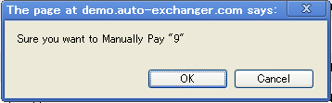

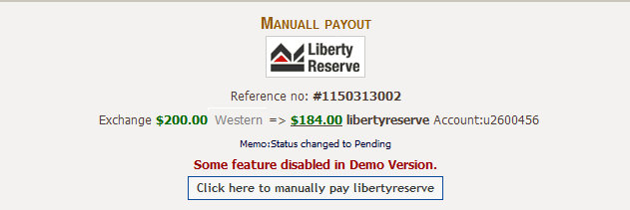

### <Admin>View Exchange Rates

#### Use Case Diagram



#### Use Case Specification

|  |  |  |  |  |
| --- | --- | --- | --- | --- |
| **USE CASE- View Exchange Rates SPECIFICATION** | | | | |
| **Use-case No.** | UC.A008 | **Use-case Version** | | 1.0 |
| **Use-case Name** | View Exchange Rates | | | |
| **Author** | HoaHM | | | |
| **Date** | 13/04/2012 | **Priority** | Normal | |
| **Actor:**  Admin  **Summary:**  Admin can view the rate between two currencies on the rate matrix  **Goal:**  View the rate between two currencies  **Triggers**  Click to “Exchange rates” menu item or “Exchange rates currencies” hyperlink  **Preconditions:**  Logged into the system successful and open the Admin Home page  **Post Conditions:**  Admin will stay in the Exchange rates page  **Main Success Scenario:**   |  |  |  | | --- | --- | --- | | Step | Actor Action | System Response | | 1 | Click to “Exchange rates” menu item | Redirect admin into Exchange rates page |   **Alternative Scenarios:**   |  |  |  | | --- | --- | --- | | Step | Actor Action | System Response | | 1 | Click to “Exchange rates currencies” hyperlink | Redirect admin into Exchange rates page |   **Exceptions:**  None  **Relationships:**  Log in use case, Admin Home page.  **Business Rules:**   |  |  |  | | --- | --- | --- | |  | Business Rule | Error Message | | 1 | The relationship between will be displayed in the matrix form |  | | 2 | The column and row will show all currencies |  | | 3 | The cross line will be blank (same currencies) |  | | | | | |

**Screen**

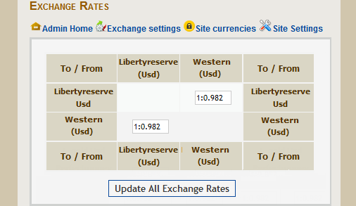

### <Admin>Update Exchange Rates

#### Use Case Diagram



#### Use Case Specification

|  |  |  |  |  |
| --- | --- | --- | --- | --- |
| **USE CASE – Update Exchange Rates SPECIFICATION** | | | | |
| **Use-case No.** | UC.A009 | **Use-case Version** | | 1.0 |
| **Use-case Name** | Update Exchange Rates | | | |
| **Author** | HoaHM | | | |
| **Date** | 13/04/2012 | **Priority** | High | |
| **Actor:**  Admin  **Summary:**  When admin want to update the rate between two currencies, this use case allow admin to update rates  **Goal:**  Update rates  **Triggers**  Admin click on “Update All Exchange Rates” button  **Preconditions:**  Access the website  **Post Conditions:**  The page will refresh and the changed result will be shown  **Main Success Scenario:**   |  |  |  | | --- | --- | --- | | Step | Actor Action | System Response | | 1 | Change some rates in textbox |  | | 2 | Click on “Update All Exchange Rates” button | Message “Updated successfully” is displayed. |   **Exceptions:**  N/A  **Relationships:**  Log in, View admin Home page, View Exchange Rates  **Business Rules:**  None | | | | |

**Screen**

****

### <Admin>View active exchange settings

#### Use Case Diagram



#### Use Case Specification

|  |  |  |  |  |
| --- | --- | --- | --- | --- |
| **USE CASE – View active exchange settings SPECIFICATION** | | | | |
| **Use-case No.** | UC.A010 | **Use-case Version** | | 1.0 |
| **Use-case Name** | View active exchange settings | | | |
| **Author** | HoaHM | | | |
| **Date** | 13/04/2012 | **Priority** | High | |
| **Actor:**  Admin  **Summary:**  This use case is allow admin to view active exchange setting, all currencies that its “Exchange Status” is Yes  **Goal:**  View all active exchanges setting  **Triggers**  Click on “Exchange setting” menu item or click on “Exchange setting parameters” hyperlink  **Preconditions:**  Login in website successfully and load Admin home page successfully  **Post Conditions:**  The page navigates to search result screen with the result displayed  **Main Success Scenario:**   |  |  |  | | --- | --- | --- | | Step | Actor Action | System Response | | 1 | Click on “Exchange setting” menu item | The system will display Exchange Settings page |   **Alternative Scenario:**   |  |  |  | | --- | --- | --- | | Step | Actor Action | System Response | | 1 | Click on “Exchange setting parameters” hyperlink | The system will display Exchange Settings page |   **Exceptions:**  N/A  **Relationships:**  Login, Admin Home Page  **Business Rules:**   |  |  |  | | --- | --- | --- | |  | Business Rule | Error Message | | 1 | Show only record whose Exchange Status is Yes |  | | | | | |

**Screen**

**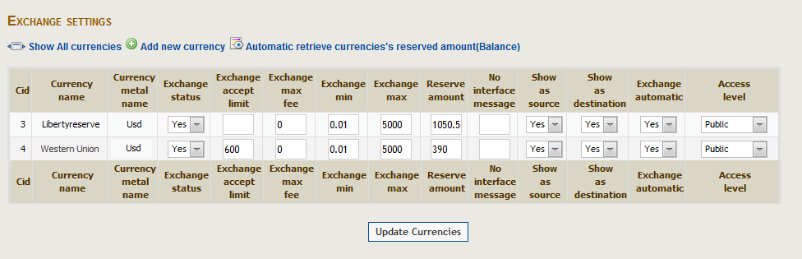**

### <Admin>View all exchange settings

#### Use Case Diagram



#### Use Case Specification

|  |  |  |  |  |
| --- | --- | --- | --- | --- |
| **USE CASE- View all exchange settings SPECIFICATION** | | | | |
| **Use-case No.** | UC.A011 | **Use-case Version** | | 1.0 |
| **Use-case Name** | View all exchange settings | | | |
| **Author** | HoaHM | | | |
| **Date** | 13/04/2012 | **Priority** | Normal | |
| **Actor:**  Admin  **Summary:**  This use case is allow admin to view all exchange settings, all currencies  **Goal:**  View all exchange settings, all currencies  **Triggers**  Click on “Show All currencies”  **Preconditions:**  Successfully logged into the system and open Active Exchange Settings page.  **Post Conditions:**  Stay remains at Exchange Settings page  **Main Success Scenario:**   |  |  |  | | --- | --- | --- | | Step | Actor Action | System Response | | 1 | Click on “Show All currencies” | System open Active Exchange Settings page |   **Exceptions:**  N/A  **Relationships:**  Log in use case, View active exchange settings use case.  **Business Rules:**   |  |  |  | | --- | --- | --- | |  | Business Rule | Error Message | | 1 | Show all the exchange setting |  | | 2 | Bachground of currency whose Exchange status is “No” will be different with “Yes” Exchange Status |  | | | | | |

**Screen**

**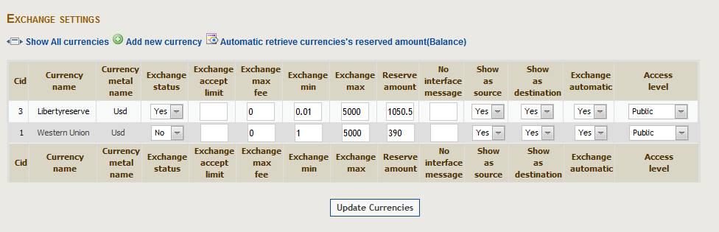**

### <Admin>Add new currency

#### Use Case Diagram



#### Use Case Specification

|  |  |  |  |  |
| --- | --- | --- | --- | --- |
| **USE CASE- Add new currency SPECIFICATION** | | | | |
| **Use-case No.** | UC.A012 | **Use-case Version** | | 1.0 |
| **Use-case Name** | Add new currency | | | |
| **Author** | HoaHM | | | |
| **Date** | 13/04/2012 | **Priority** | Normal | |
| **Actor:**  Admin  **Summary:**  When admin want to add new currency into system  **Goal:**  Allows admin add new currency into system.  **Triggers**  Click to “Add new currency” hyperlink in Exchange Settings page.  **Preconditions:**  Successfully logged into the system and Exchange Setting page  **Post Conditions:**  Stay remain in Exchange Setting page  **Main Success Scenario:**   |  |  |  | | --- | --- | --- | | Step | Actor Action | System Response | | 1 | Click to “Add new currency” hyperlink | Redirect to “Add new currency” page | | 2 | Input all information about new currency |  | | 3 | Click “Update currencies” button | The new currency will be added into “Exchange Setting Rate” pages |   **Exceptions:**  N/A  **Relationships:**  Log in use case, View Exchange Setting page.  **Business Rules:**  N/A | | | | |

**Screen**

**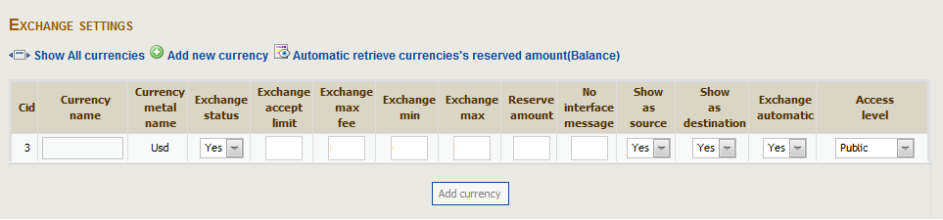**

### <Admin>Update currencies

#### Use Case Diagram



#### Use Case Specification

|  |  |  |  |  |
| --- | --- | --- | --- | --- |
| **USE CASE – Update currencies SPECIFICATION** | | | | |
| **Use-case No.** | UC.A013 | **Use-case Version** | | 1.0 |
| **Use-case Name** | Update currencies | | | |
| **Author** | HoaHM | | | |
| **Date** | 13/04/2012 | **Priority** | High | |
| **Actor:**  Admin  **Summary:**  When admin want to update many currencies such as max limit or min limit,….  **Goal:**  Update currencies  **Triggers**  Click on “Update currencies”  **Preconditions:**  Successfully logged into the system and open view Exchange Setting page  **Post Conditions:**  Stay remains at Exchange Setting page.  **Main Success Scenario:**   |  |  |  | | --- | --- | --- | | Step | Actor Action | System Response | | 1 | Change some information of currencies |  | | 2 | Click on “Update currencies” | Show message “Update successfully” and stay remain in “View all exchange setting” |   **Exceptions: -**  **Relationships:**  Log in use case, View active exchange setting use case  **Business Rules:**  N/A | | | | |

**Screen**

****

****

****

### <Admin>View all member

#### Use Case Diagram



#### Use Case Specification

|  |  |  |  |  |
| --- | --- | --- | --- | --- |
| **USE CASE – View all member SPECIFICATION** | | | | |
| **Use-case No.** | UC.A014 | **Use-case Version** | | 1.0 |
| **Use-case Name** | View all member | | | |
| **Author** | HoaHM | | | |
| **Date** | 13/04/2012 | **Priority** | High | |
| **Actor:**  Admin  **Summary:**  When admin want to manage all of members in system to view their relevant information. Allow/reject use system.  **Goal:**  Show all members’ information  **Triggers**  Click on ”Manage member” menu item or “User manager” hyperlink from Admin Home Page  **Preconditions:**  Successfully logged into the system and open Admin Home Page  **Post Conditions:**  Stay remain at “Members Management” page.  **Main Success Scenario:**   |  |  |  | | --- | --- | --- | | Step | Actor Action | System Response | | 1 | Click on ”Manage member” menu item | “Member Management” will be loaded |   **Alternative Scenario:**   |  |  |  | | --- | --- | --- | | Sep | Actor Action | System Response | | 1 | Click on “User manager” hyperlink from Admin Home Page | “Member Management” will be loaded |   **Exceptions:**  N/A  **Relationships:**  Log in use case , View Admin Home Page use case  **Business Rules:**   |  |  |  | | --- | --- | --- | | **No** | **Rule Description** | **Error Message** | | 1 | Show all the members in this system, ordered by ID |  | | 2 | Show the total members in the bottom of grid |  | | 3 | When system has no member. |  | | | | | |

**Screen**

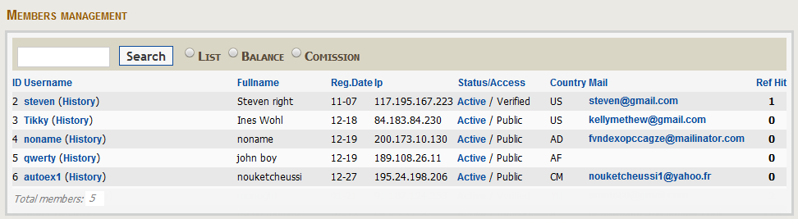

### <Admin>Search member

#### Use Case Diagram



#### Use Case Specification

|  |  |  |  |  |
| --- | --- | --- | --- | --- |
| **USE CASE – Search member SPECIFICATION** | | | | |
| **Use-case No.** | UC.A015 | **Use-case Version** | | 1.0 |
| **Use-case Name** | Search member | | | |
| **Author** | HoaHM | | | |
| **Date** | 13/04/2012 | **Priority** | Normal | |
| **Actor:**  Admin  **Summary:**  When total of memebers is large and the admin want to narrow the result or find out exactly member based on the inputted conditions.  **Goal:**  Narrow the list or specify exactly memebr .  **Triggers**  Move the mouse to a comment and click to button with thumb up symbol or button with thumb down symbol  **Preconditions:**  Successfully logged into the system and open “Member Management” page  **Post Conditions:**  Stay remain at “Member Management” page  **Main Success Scenario:**   |  |  |  | | --- | --- | --- | | Step | Actor Action | System Response | | 1 | Input the condition into textbox search |  | | 2 | Click on “Search” button | The list result will return based on the inputted condition |   **Alternative Scenario:**   |  |  |  | | --- | --- | --- | | Step | Actor Action | System Response | | 1 | Input the condition into textbox search |  | | 2 | Press “Enter” key | The list result will return based on the inputted condition |   **Exceptions:**  **Relationships:**  Log in use case  **Business Rules:**   |  |  |  | | --- | --- | --- | | **No** | **Rule Description** | **Error Message** | | 1 | Show all the result matching with inputted condition |  | | 2 | In this case there has no results | There is not any member to List | | | | | |

**Screen**

**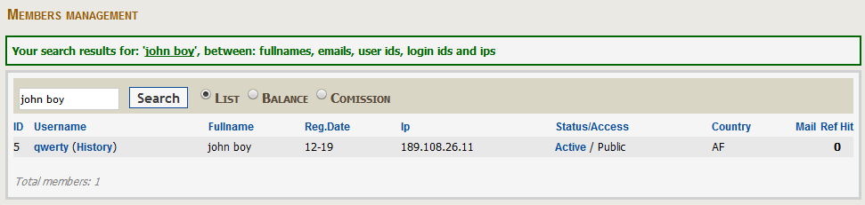**

**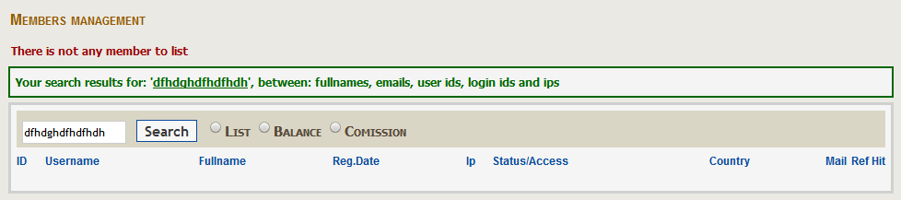**

### <Admin>View detail member

#### Use Case Diagram



#### Use Case Specification

|  |  |  |  |  |
| --- | --- | --- | --- | --- |
| **USE CASE – View detail member SPECIFICATION** | | | | |
| **Use-case No.** | UC.A016 | **Use-case Version** | | 1.0 |
| **Use-case Name** | View detail member | | | |
| **Author** | HoaHM | | | |
| **Date** | 13/04/2012 | **Priority** | Normal | |
| **Actor:**  User  **Summary:**  Admin wants to view detail of each member  **Goal:**  Show detail of memeber  **Triggers**  Click on “Username”  **Preconditions:**  Access the website and List of user existed  **Post Conditions:**  Stay remains at “Members Management” page  **Main Success Scenario:**   |  |  |  | | --- | --- | --- | | Step | Actor Action | System Response | | 1 | Click on username of member | Redirect Admin to “Edit Member” page with all information |   **Exceptions:**  **N/A**  **Relationships:**  Log in use case, View All Member  **Business Rules:**  N/A | | | | |

**Screen**

**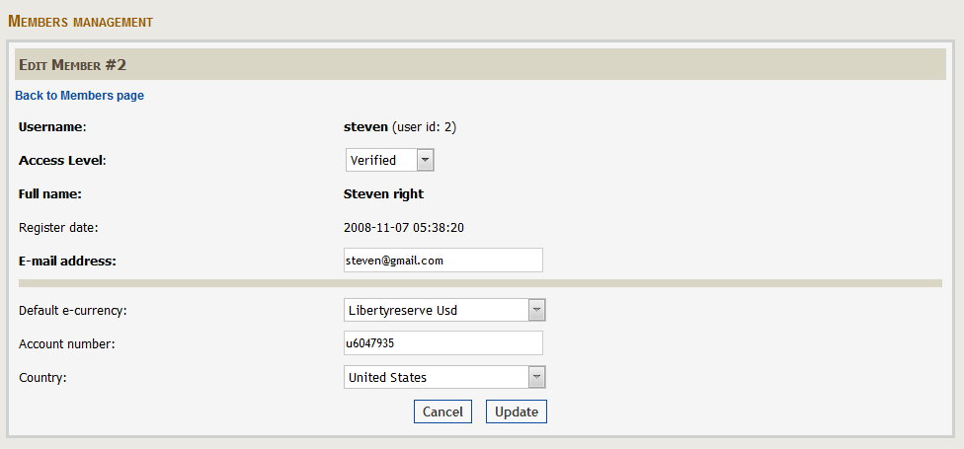**

### <Admin>Update member

#### Use Case Diagram



#### Use Case Specification

|  |  |  |  |  |
| --- | --- | --- | --- | --- |
| **USE CASE – Update member SPECIFICATION** | | | | |
| **Use-case No.** | UC.A017 | **Use-case Version** | | 1.0 |
| **Use-case Name** | Update member | | | |
| **Author** | HoaHM | | | |
| **Date** | 13/04/2012 | **Priority** | High | |
| **Actor:**  Admin  **Summary:**  Admin wants to change some information of memeber  **Goal:**  Change information of member  **Triggers**  Click “Update” button  **Preconditions:**  Successfully logged into the system and open view detail member page  **Post Conditions:**  Stay remain at view detail member page  **Main Success Scenario:**   |  |  |  | | --- | --- | --- | | Step | Actor Action | System Response | | 1 | Change some information of member |  | | 2 | Click on “update” button | Message will shown “Member (#xxx) updated successfully” |   **Exceptions:**  N/A  **Relationships:**  Log in use case , View Detail member use case  **Business Rules:**  N/A | | | | |

**Screen**

**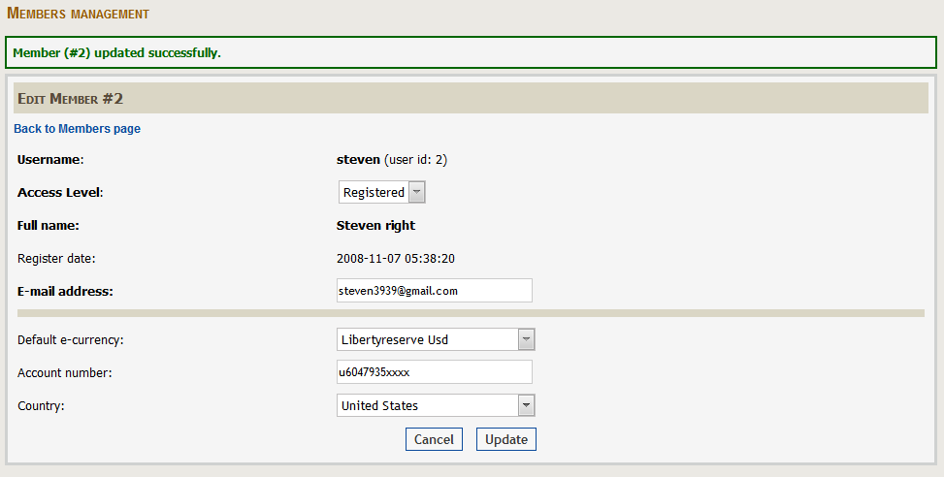**

### <Admin>View currency information & password

#### Use Case Diagram



#### Use Case Specification

|  |  |  |  |  |
| --- | --- | --- | --- | --- |
| **USE CASE - <Admin> View currency infor & password SPECIFICATION** | | | | |
| **Use-case No.** | UC.A018 | **Use-case Version** | | 1.0 |
| **Use-case Name** | <Admin> View currency information & password | | | |
| **Author** | TungNS | | | |
| **Date** | 12/04/2012 | **Priority** | Normal | |
| **Actor:**  Admin  **Summary:**  This use case allows the admin to view specific currency infor & password of this currency  **Goal:**  Allows the admin to view specific currency infor & password of this currency  **Triggers**  N/A  **Preconditions:**  Admin logged into the system successfully  **Post Conditions:**  N/A  **Main Success Scenario:**   |  |  |  | | --- | --- | --- | | Step | Actor Action | System Response | | 1 | Click on “site currencies” on navigator at admin page | Redirect to view site currencies page |   **Alternative Scenario:**  N/A  **Exceptions:**  N/A  **Relationships:**  Login admin use case  **Business Rules:**  None | | | | |

**Screen:**

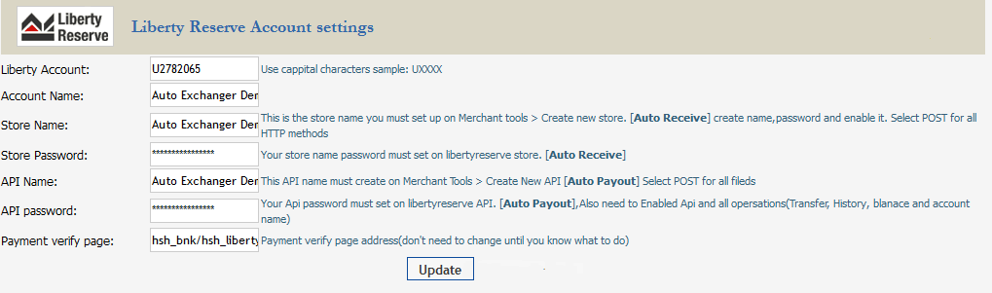

### <Admin>Update site currency & password

#### Use Case Diagram



#### Use Case Specification

|  |  |  |  |  |
| --- | --- | --- | --- | --- |
| **USE CASE - <Admin> Update currency infor & password SPECIFICATION** | | | | |
| **Use-case No.** | UC.A019 | **Use-case Version** | | 1.0 |
| **Use-case Name** | <Admin> Update currency infor & password | | | |
| **Author** | TungNS | | | |
| **Date** | 12/04/2012 | **Priority** | Normal | |
| **Actor:**  Admin  **Summary:**  This use case allows the admin to update specific currency infor & password of this currency  **Goal:**  Allows the admin to update specific currency infor & password of this currency  **Triggers**  N/A  **Preconditions:**  Admin logged into the system successfully  **Post Conditions:**  N/A  **Main Success Scenario:**   |  |  |  | | --- | --- | --- | | Step | Actor Action | System Response | | 1 |  | Display site currencies page | | 2 | Admin change the infor of currency and password |  | | 3 | Admin click button “Update” | Update the currency infor & password to DB | | 4 |  | Display new currency infor & password |   **Alternative Scenario:**  N/A  **Exceptions:**  N/A  **Relationships:**  Login admin use case  **Business Rules:**  None | | | | |

**Screen:**



### <Admin>View general site setting

#### Use Case Diagram



#### Use Case Specification

|  |  |  |  |  |
| --- | --- | --- | --- | --- |
| **USE CASE - <Admin> View general site setting SPECIFICATION** | | | | |
| **Use-case No.** | UC.A020 | **Use-case Version** | | 1.0 |
| **Use-case Name** | <Admin> View general site setting | | | |
| **Author** | TungNS | | | |
| **Date** | 12/04/2012 | **Priority** | Normal | |
| **Actor:**  Admin  **Summary:**  This use case allows the admin to view general setting of site  **Goal:**  Allows the admin to view general setting of site  **Triggers**  N/A  **Preconditions:**  Admin logged into the system successfully  **Post Conditions:**  N/A  **Main Success Scenario:**   |  |  |  | | --- | --- | --- | | Step | Actor Action | System Response | | 1 | Click on “site setting” on navigator at admin page | Redirect to view site setting page |   **Alternative Scenario:**   |  |  |  | | --- | --- | --- | | Step | Actor Action | System Response | | 1 | Click to tab “general” on tab of site setting page | Redirect to view general tab |   **Alternative Scenario:**  N/A  **Exceptions:**  N/A  **Relationships:**  Login admin use case  **Business Rules:**  None | | | | |

Screen:

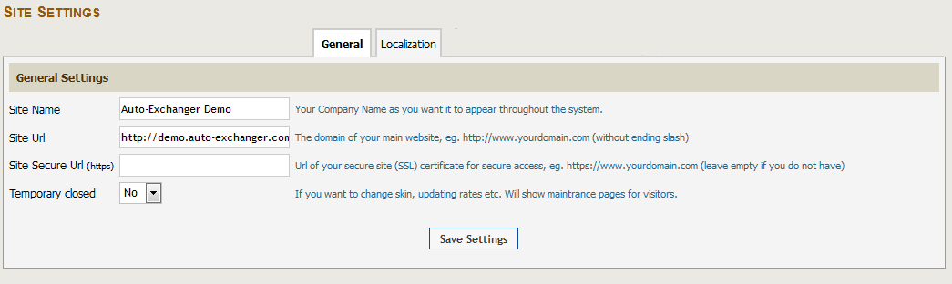

### <Admin>Edit general site setting

#### Use Case Diagram



#### Use Case Specification

|  |  |  |  |  |
| --- | --- | --- | --- | --- |
| **USE CASE - <Admin> Edit general site setting SPECIFICATION** | | | | |
| **Use-case No.** | UC.A021 | **Use-case Version** | | 1.0 |
| **Use-case Name** | <Admin> Edit general site setting | | | |
| **Author** | TungNS | | | |
| **Date** | 12/04/2012 | **Priority** | Normal | |
| **Actor:**  Admin  **Summary:**  This use case allows the admin to edit general site setting  **Goal:**  Allows the admin to edit general site setting  **Triggers**  System is displaying general site setting page  **Preconditions:**  Admin logged into the system successfully  **Post Conditions:**  N/A  **Main Success Scenario:**   |  |  |  | | --- | --- | --- | | Step | Actor Action | System Response | | 1 |  | Display general site setting page | | 2 | Admin edit general site setting |  | | 3 | Admin click button “Save Settings” | Update the general site setting to DB | | 4 |  | Display new general site setting |   **Alternative Scenario:**  N/A  **Exceptions:**  N/A  **Relationships:**  Login admin use case  View general site setting  **Business Rules:**  None | | | | |

Screen:



### <Admin>View localization site setting

#### Use Case Diagram



#### Use Case Specification

|  |  |  |  |  |
| --- | --- | --- | --- | --- |
| **USE CASE - <Admin> View localization site setting SPECIFICATION** | | | | |
| **Use-case No.** | UC.A022 | **Use-case Version** | | 1.0 |
| **Use-case Name** | <Admin> View localization site setting | | | |
| **Author** | TungNS | | | |
| **Date** | 12/04/2012 | **Priority** | Normal | |
| **Actor:**  Admin  **Summary:**  This use case allows the admin to view localization site setting  **Goal:**  Allows the admin to view localization site setting  **Triggers**  User is viewing site setting – general tab  **Preconditions:**  Admin logged into the system successfully  **Post Conditions:**  N/A  **Main Success Scenario:**   |  |  |  | | --- | --- | --- | | Step | Actor Action | System Response | | 1 | Click on “Localization” tab in site setting | Redirect to view localization site setting page |   **Alternative Scenario:**  N/A  **Exceptions:**  N/A  **Relationships:**  Login admin use case  View general site setting  **Business Rules:**  None | | | | |

**Screen:**

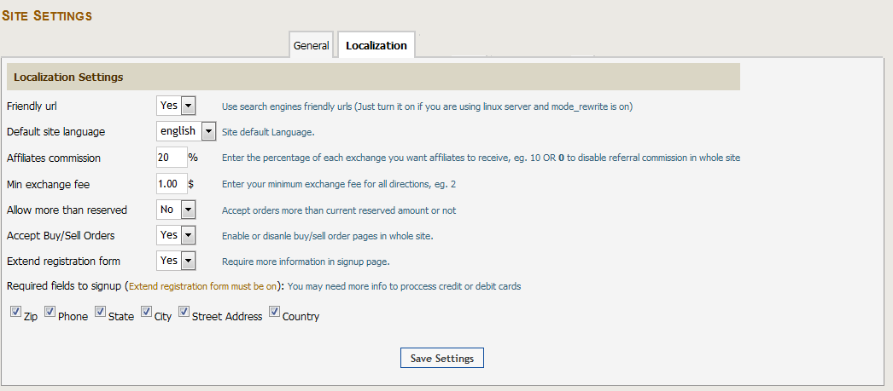

### <Admin>Edit localization site setting

#### Use Case Diagram



#### Use Case Specification

|  |  |  |  |  |
| --- | --- | --- | --- | --- |
| **USE CASE - <Admin> Edit localization site setting SPECIFICATION** | | | | |
| **Use-case No.** | UC.A023 | **Use-case Version** | | 1.0 |
| **Use-case Name** | <Admin> Edit localization site setting | | | |
| **Author** | TungNS | | | |
| **Date** | 12/04/2012 | **Priority** | Normal | |
| **Actor:**  Admin  **Summary:**  This use case allows the admin to edit localization site setting  **Goal:**  Allows the admin to edit loclization site setting  **Triggers**  System is displaying localization site setting page  **Preconditions:**  Admin logged into the system successfully  **Post Conditions:**  N/A  **Main Success Scenario:**   |  |  |  | | --- | --- | --- | | Step | Actor Action | System Response | | 1 |  | Display localization site setting page | | 2 | Admin edit localization site setting |  | | 3 | Admin click button “Save settings” | Update the localization site setting to DB | | 4 |  | Display new localization site setting |   **Alternative Scenario:**  N/A  **Exceptions:**  N/A  **Relationships:**  Login admin use case  View localization site setting  **Business Rules:**  None | | | | |

**Screen:**



### <Admin>View all news

#### Use Case Diagram



#### Use Case Specification

|  |  |  |  |  |
| --- | --- | --- | --- | --- |
| **USE CASE - <Admin> View all news SPECIFICATION** | | | | |
| **Use-case No.** | UC.A024 | **Use-case Version** | | 1.0 |
| **Use-case Name** | <Admin> View all news | | | |
| **Author** | TungNS | | | |
| **Date** | 12/04/2012 | **Priority** | Normal | |
| **Actor:**  Admin  **Summary:**  This use case allows the admin to view all news  **Goal:**  Allows the admin to view all news  **Triggers**  N/A  **Preconditions:**  Admin logged into the system successfully  **Post Conditions:**  N/A  **Main Success Scenario:**   |  |  |  | | --- | --- | --- | | Step | Actor Action | System Response | | 1 | Click on “News” on navigator at admin page | Redirect to view all news page |   **Alternative Scenario:**  N/A  **Exceptions:**  N/A  **Relationships:**  Login admin use case  **Business Rules:**  None | | | | |

Screen:

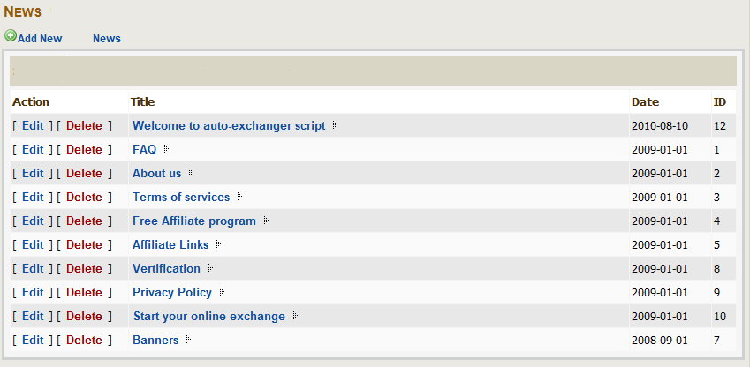

### <Admin>View details of a news

#### Use Case Diagram



#### Use Case Specification

|  |  |  |  |  |
| --- | --- | --- | --- | --- |
| **USE CASE - <Admin> View details of a news SPECIFICATION** | | | | |
| **Use-case No.** | UC.A025 | **Use-case Version** | | 1.0 |
| **Use-case Name** | <Admin> View details of a news | | | |
| **Author** | TungNS | | | |
| **Date** | 12/04/2012 | **Priority** | Normal | |
| **Actor:**  Admin  **Summary:**  This use case allows the admin to view details of a news  **Goal:**  Allows the admin to view details of a news  **Triggers**  System is displaying all news  **Preconditions:**  Admin logged into the system successfully  **Post Conditions:**  N/A  **Main Success Scenario:**   |  |  |  | | --- | --- | --- | | Step | Actor Action | System Response | | 1 |  | Display all news page | | 2 | Admin click to a news in news list | Display details of the news |   **Alternative Scenario:**  N/A  **Exceptions:**  N/A  **Relationships:**  Login admin use case  View all news  **Business Rules:**  None | | | | |

Sceen:



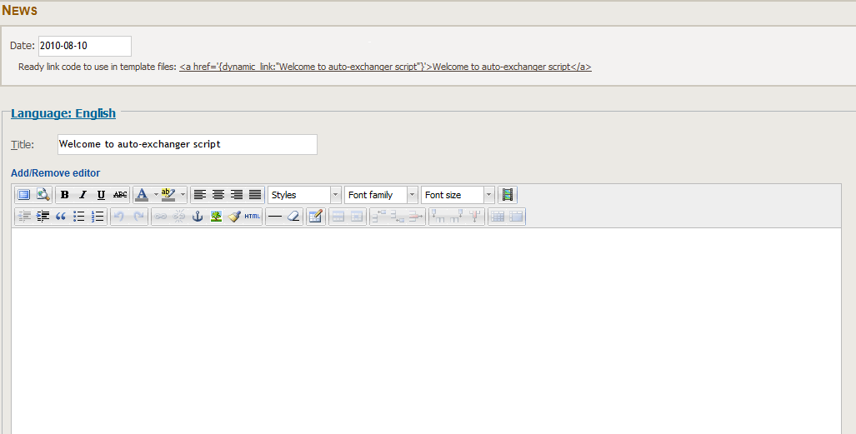

### <Admin>Add a news

#### Use Case Diagram



#### Use Case Specification

|  |  |  |  |  |
| --- | --- | --- | --- | --- |
| **USE CASE - <Admin> Add a news SPECIFICATION** | | | | |
| **Use-case No.** | UC.A026 | **Use-case Version** | | 1.0 |
| **Use-case Name** | <Admin> Add a news | | | |
| **Author** | TungNS | | | |
| **Date** | 12/04/2012 | **Priority** | Normal | |
| **Actor:**  Admin  **Summary:**  This use case allows the admin to add a news  **Goal:**  Allows the admin to add a news  **Triggers**  System is displaying all news  **Preconditions:**  Admin logged into the system successfully  **Post Conditions:**  N/A  **Main Success Scenario:**   |  |  |  | | --- | --- | --- | | Step | Actor Action | System Response | | 1 |  | Display all news page | | 2 | Admin click to button “Add a news” | Display details of new news | | 3 | Admin add the infor of the news |  | | 4 | Admin click “Save” button | Save the news | | 5 |  | Redirect to the view all news page |   **Alternative Scenario:**  N/A  **Exceptions:**   |  |  |  | | --- | --- | --- | | Step | Actor Action | System Response | | 1 |  | Display all news page | | 2 | Admin click to button “Add a news” | Display details of new news | | 3 | Admin add the infor of the news |  | | 4 | Admin click “Cancel” button | Do not save the news | | 5 |  | Redirect to the view all news page |   **Relationships:**  Login admin use case  View all news  **Business Rules:**  None | | | | |

Screen:





### <Admin>Update a news

#### Use Case Diagram



#### Use Case Specification

|  |  |  |  |  |
| --- | --- | --- | --- | --- |
| **USE CASE - <Admin> Update a news SPECIFICATION** | | | | |
| **Use-case No.** | UC.A027 | **Use-case Version** | | 1.0 |
| **Use-case Name** | <Admin> Update a news | | | |
| **Author** | TungNS | | | |
| **Date** | 12/04/2012 | **Priority** | Normal | |
| **Actor:**  Admin  **Summary:**  This use case allows the admin to update a news  **Goal:**  Allows the admin to update a news  **Triggers**  System is displaying all news  **Preconditions:**  Admin logged into the system successfully  **Post Conditions:**  N/A  **Main Success Scenario:**   |  |  |  | | --- | --- | --- | | Step | Actor Action | System Response | | 1 |  | Displays all news page | | 2 | Admin click to button “Update” beside a news | Displays details of news, which user want to update | | 3 | Admin update the infor of the news |  | | 4 | Admin click “Save” button | Save the news | | 5 |  | Redirect to the view all news page |   **Alternative Scenario:**  N/A  **Exceptions:**   |  |  |  | | --- | --- | --- | | Step | Actor Action | System Response | | 1 |  | Displays all news page | | 2 | Admin click to button “Update” beside a news | Displays details of new news | | 3 | Admin add the infor of the news |  | | 4 | Admin click “Cancel” button | Do not save the news | | 5 |  | Redirect to the view all news page |   **Relationships:**  Login admin use case  View all news  **Business Rules:**  None | | | | |

Screen:





### <Admin>Delete a news

#### Use Case Diagram



#### Use Case Specification

|  |  |  |  |  |
| --- | --- | --- | --- | --- |
| **USE CASE - <Admin> Delete a news SPECIFICATION** | | | | |
| **Use-case No.** | UC.A028 | **Use-case Version** | | 1.0 |
| **Use-case Name** | <Admin> Delete a news | | | |
| **Author** | TungNS | | | |
| **Date** | 12/04/2012 | **Priority** | Normal | |
| **Actor:**  Admin  **Summary:**  This use case allows the admin to delete a news  **Goal:**  Allows the admin to delete a news  **Triggers**  System is displaying all news  **Preconditions:**  Admin logged into the system successfully  **Post Conditions:**  N/A  **Main Success Scenario:**   |  |  |  | | --- | --- | --- | | Step | Actor Action | System Response | | 1 |  | Display all news page | | 2 | Admin click to button “Delete” beside a news | Display message box “Are you sure you want to delete this news?” | | 3 | Admin click to button “Ok” | Delete this news | | 5 |  | Redirect to the view all news page |   **Alternative Scenario:**  N/A  **Exceptions:**   |  |  |  | | --- | --- | --- | | Step | Actor Action | System Response | | 1 |  | Display all news page | | 2 | Admin click to button “Delete” beside a news | Display message box “Are you sure you want to delete this news?” | | 3 | Admin click to button “Cancel” | Do not delete this news | | 5 |  | Redirect to the view all news page |   **Relationships:**  Login admin use case  View all news  **Business Rules:**  None | | | | |

Screen:



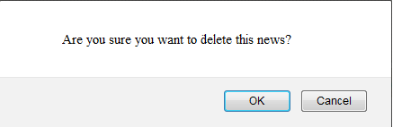

### <Admin>View all pages

#### Use Case Diagram



#### Use Case Specification

|  |  |  |  |  |
| --- | --- | --- | --- | --- |
| **USE CASE - <Admin> View all pages SPECIFICATION** | | | | |
| **Use-case No.** | UC.A029 | **Use-case Version** | | 1.0 |
| **Use-case Name** | <Admin> View all pages | | | |
| **Author** | TungNS | | | |
| **Date** | 12/04/2012 | **Priority** | Normal | |
| **Actor:**  Admin  **Summary:**  This use case allows the admin to view all pages  **Goal:**  Allows the admin to view all pages  **Triggers**  N/A  **Preconditions:**  Admin logged into the system successfully  **Post Conditions:**  N/A  **Main Success Scenario:**   |  |  |  | | --- | --- | --- | | Step | Actor Action | System Response | | 1 | Click on “Pages” on navigator at admin page | Redirect to view all pages |   **Alternative Scenario:**  N/A  **Exceptions:**  N/A  **Relationships:**  Login admin use case  **Business Rules:**  None | | | | |

Screen:

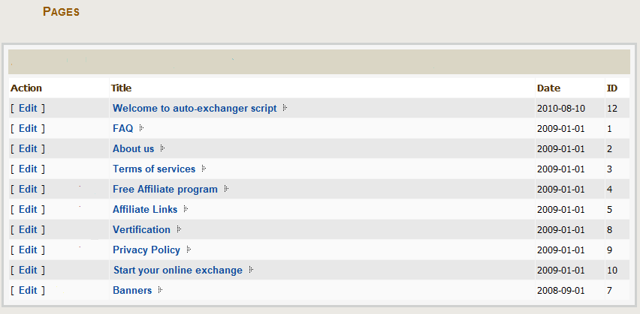

### <Admin>View details of a page

#### Use Case Diagram



#### Use Case Specification

|  |  |  |  |  |
| --- | --- | --- | --- | --- |
| **USE CASE - <Admin> View details of a page SPECIFICATION** | | | | |
| **Use-case No.** | UC.A030 | **Use-case Version** | | 1.0 |
| **Use-case Name** | <Admin> View details of a page | | | |
| **Author** | TungNS | | | |
| **Date** | 12/04/2012 | **Priority** | Normal | |
| **Actor:**  Admin  **Summary:**  This use case allows the admin to view details of a page  **Goal:**  Allows the admin to view details of a page  **Triggers**  System is displaying all pages  **Preconditions:**  Admin logged into the system successfully  **Post Conditions:**  N/A  **Main Success Scenario:**   |  |  |  | | --- | --- | --- | | Step | Actor Action | System Response | | 1 |  | Display all pages | | 2 | Admin click to a page in pages list | Display details of the page |   **Alternative Scenario:**  N/A  **Exceptions:**  N/A  **Relationships:**  Login admin use case  View all pages  **Business Rules:**  None | | | | |

Screen:



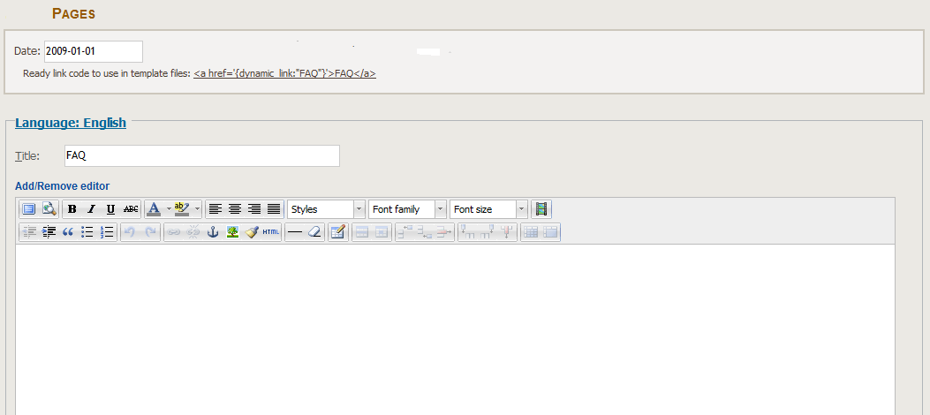

### <Admin>Update a page

#### Use Case Diagram



#### Use Case Specification

|  |  |  |  |  |
| --- | --- | --- | --- | --- |
| **USE CASE - <Admin> Update a page SPECIFICATION** | | | | |
| **Use-case No.** | UC.A031 | **Use-case Version** | | 1.0 |
| **Use-case Name** | <Admin> Update a page | | | |
| **Author** | TungNS | | | |
| **Date** | 12/04/2012 | **Priority** | Normal | |
| **Actor:**  Admin  **Summary:**  This use case allows the admin to update a page  **Goal:**  Allows the admin to update a page  **Triggers**  System is displaying all pages  **Preconditions:**  Admin logged into the system successfully  **Post Conditions:**  N/A  **Main Success Scenario:**   |  |  |  | | --- | --- | --- | | Step | Actor Action | System Response | | 1 |  | Display all pages | | 2 | Admin click to button “Update” beside a page | Display details of page, which user want to update | | 3 | Admin update the infor of the pages |  | | 4 | Admin click “Save” button | Save the page | | 5 |  | Redirect to the view all pages |   **Alternative Scenario:**  N/A  **Exceptions:**   |  |  |  | | --- | --- | --- | | Step | Actor Action | System Response | | 1 |  | Display all pages | | 2 | Admin click to button “Update” beside a page | Display details of page, which user want to update | | 3 | Admin update the infor of the pages |  | | 4 | Admin click “Cancel” button | Do not save the page | | 5 |  | Redirect to the view all pages |   **Relationships:**  Login admin use case  View all pages  **Business Rules:**  None | | | | |

Screen:





### <Admin>View profiles

#### Use Case Diagram



#### Use Case Specification

|  |  |  |  |  |
| --- | --- | --- | --- | --- |
| **USE CASE - <Admin> View profiles SPECIFICATION** | | | | |
| **Use-case No.** | UC.A032 | **Use-case Version** | | 1.0 |
| **Use-case Name** | <Admin> View profiles | | | |
| **Author** | TungNS | | | |
| **Date** | 12/04/2012 | **Priority** | Normal | |
| **Actor:**  Admin  **Summary:**  This use case allows the admin to view profiles  **Goal:**  Allows the admin to view profiles  **Triggers**  N/A  **Preconditions:**  Admin logged into the system successfully  **Post Conditions:**  N/A  **Main Success Scenario:**   |  |  |  | | --- | --- | --- | | Step | Actor Action | System Response | | 1 | Click on “Profiles” on navigator at admin page | Redirect to view profiles page |   **Alternative Scenario:**  N/A  **Exceptions:**  N/A  **Relationships:**  Login admin use case  **Business Rules:**  None | | | | |

Screen:

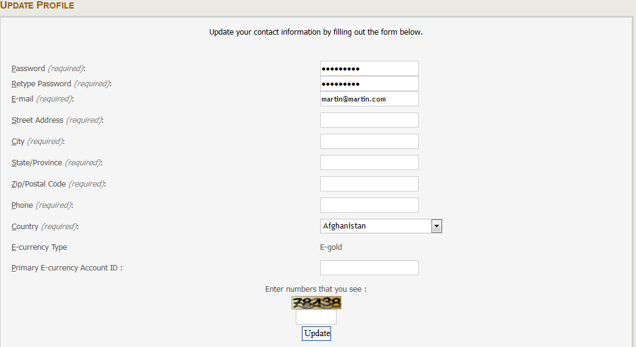

### <Admin>Update profile

#### Use Case Diagram



#### Use Case Specification

|  |  |  |  |  |
| --- | --- | --- | --- | --- |
| **USE CASE - <Admin> Update profiles SPECIFICATION** | | | | |
| **Use-case No.** | UC.A033 | **Use-case Version** | | 1.0 |
| **Use-case Name** | <Admin> Update profiles | | | |
| **Author** | TungNS | | | |
| **Date** | 12/04/2012 | **Priority** | Normal | |
| **Actor:**  Admin  **Summary:**  This use case allows the admin to update profiles  **Goal:**  Allows the admin to update profiles  **Triggers**  N/A  **Preconditions:**  Admin logged into the system successfully  **Post Conditions:**  N/A  **Main Success Scenario:**   |  |  |  | | --- | --- | --- | | Step | Actor Action | System Response | | 1 |  | Display profiles page | | 2 | Admin update the infor of profile |  | | 3 | Admin click button “Update” | Update the profile |   **Alternative Scenario:**  N/A  **Exceptions:**  N/A  **Relationships:**  Login admin use case  View profiles  **Business Rules:**  None | | | | |

Screen:



### <Admin>Login admin

#### Use Case Diagram



#### Use Case Specification

|  |  |  |  |  |
| --- | --- | --- | --- | --- |
| **USE CASE - <Admin> Login admin SPECIFICATION** | | | | |
| **Use-case No.** | UC.A034 | **Use-case Version** | | 1.0 |
| **Use-case Name** | <Admin> Login admin | | | |
| **Author** | TungNS | | | |
| **Date** | 12/04/2012 | **Priority** | Normal | |
| **Actor:**  Users  **Summary:**  This use case allows the admin to login to admin page  **Goal:**  Allows the admin to login to admin page  **Triggers**  N/A  **Preconditions:**  Admin brower the admin page link  **Post Conditions:**  N/A  **Main Success Scenario:**   |  |  |  | | --- | --- | --- | | Step | Actor Action | System Response | | 1 |  | Display the login box | | 2 | Input the admin account, password, and capcha | Check the account, password, capcha | | 3 |  | The account, password, capcha are right; admin login sucessfully to admin page | | 4 |  | Display the admin home page |   **Alternative Scenario:**  N/A  **Exceptions:**   |  |  |  | | --- | --- | --- | | Step | Actor Action | System Response | | 1 |  | Display the login box | | 2 | Input the admin account, password, and capcha | Check the account, password, capcha | | 3 |  | The account, password, capcha are not right; admin can not login to admin page | | 4 |  | Display the login box again |   **Relationships:**  **Business Rules:**  None | | | | |

Screen:

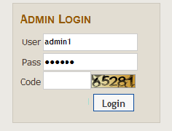

### <Admin>Logout admin

#### Use Case Diagram



#### Use Case Specification

|  |  |  |  |  |
| --- | --- | --- | --- | --- |
| **USE CASE - <Admin> Logout admin SPECIFICATION** | | | | |
| **Use-case No.** | UC.A035 | **Use-case Version** | | 1.0 |
| **Use-case Name** | <Admin> Logout admin | | | |
| **Author** | TungNS | | | |
| **Date** | 12/04/2012 | **Priority** | Normal | |
| **Actor:**  Admin  **Summary:**  This use case allows the admin to logout from admin page  **Goal:**  Allows the admin to logout from admin page  **Triggers**  N/A  **Preconditions:**  Admin logged into the system successfully  **Post Conditions:**  N/A  **Main Success Scenario:**   |  |  |  | | --- | --- | --- | | Step | Actor Action | System Response | | 1 | Admin click “logout” in navigator of the page | Logout |   **Alternative Scenario:**  N/A  **Exceptions:**  N/A  **Relationships:**  Login admin use case  **Business Rules:**  None | | | | |

Screen:

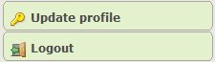

## Software System Attributes

### Usability

**GUI**

* All the text, image text and help documents should be in Vietnamese.
* The interface should be elegant, simple and out-standing.
* All images must also provide alt attribute.

**Usability for end-users**

* The website must provide a help page to support novice users.
* Users can use main functionality of the system without logging in to the system.
* The system should remember information (but not confidential) that users have to provide regularly. For example: name, address…

**Usability for admin**

* Website admin should need no more than one day of training to be productive with the system.
* Detailed help must be available for the admin ,both in web pages and separate documentations.

**Installation**

* The system must be easy to deploy. Customer can deploy successfully and learn to configure, maintain the system within one day of training.
* The documentation for installation must be included. It describes detailed steps for installing or deploying the system. The customer can follow the steps without direct help from the developing team.

### Reliability

* Initial data must be collected carefully and correctly
* The database must be backed up regularly and can be recovered if necessary
* Have a good spam filter
* Rating system must be reliable
* Not conflict with other software
* Rate of fault occurrence (ROFO): a number of 0.005 is acceptable. It means that it is acceptable to have 5 failures happen in each 1000 operational time units (e.g. 5 failures per 1000 hours of operation).
* Mean Time Between Failures (MTBF): 1 month
* Mean Time To Repair (MTTR): immediately when admin finds out problem or website is attacked by someone. Average 1 day.
* Accuracy: precision of floating number should be rounded to 0.01. All currency units must be displayed (e.g. $, VND…)
* Maximum Bugs or Defect Rate: 5 bugs / KLOC.
* Bugs or Defect Rate
  + Minor bugs: bugs related to GUI
  + Significant bugs: bugs related to minor business logic
  + Critical *bugs: function can’t execute correctly, completely loss of data, disconnect to the server*

### Availability

* Systems have to run 24 hours 7 days
* Can be turned off when upgrading and must display an alternative maintenance page in such occasions
* Percentage of time available is about 95-97%. Because the system uses client/server protocol through Internet network, we cannot control cases of force majeure such as power failure, disconnected network…

### Security

* Privacy: the system should provide protection method for protecting user information from outside or from other users. All the information of users must not be available for anyone or software that is not part of the system. User password is also invisible for the system administrator.
* The system must provide methods to prevent common security attacks. E.g. SQL injection, D-Dos…
* Transformation of confidential information must be encrypted.
* The system must provide secure methods for users to recovery their password, including the interference of system’s admin.
* Secure information of customers should not be stored on customer’s machine.
* Utilize certain cryptographic techniques for database
* Provide options for users to choose whether to share private information
* Restrict communications between some areas of the program
* Check data integrity for critical variables
* Must use secure connection (SSL) for transferring sensitive data

### Maintainability

**Coding standards and naming conventions**

* Output of the project must include coding standards and naming conventions documentations. Implementation code must be easy to maintain.
* All code must be clearly commented, including class, method documentations.
* If some components are reused, the documentations of those components must also be included.

**Design**

* The design of the system must be loosely coupled that chances on some module will not affect others.

**Logging**

* All the errors should be logged, supporting for bug fixing and maintenance.
* All strange or sensitive situations should also be logged.

**Support**

* The system must provide an Yahoo Messenger ID or Skype ID to support guests when they need

### Portability

* Website can be used by any people with a browser and an Internet connection.

### Performance

**Load time**

* Every page should be completely displayed within: average 1.5 second and maximum 5 seconds.
* Comments and rating and the like should affect immediately, without reloading the web page.
* Frequently accessed data must be cached
* Reference *data must be cached*

**Mailing system**

* Mail server should send emails within 1 minute after associated events happen.

**Capacity**

* The system should serve correctly and reasonably with at least 1000 online guests at a moment.
* The system can store at least 10000 transactions in 1 moment without affecting the loading speed.
* If the system is busy, it has to inform users about that.

**Compatibility**

* The system should provide elegant responses for nowadays common screen resolutions: 1024\*768, 1280\*800.
* The output must be compatible with all common browsers: Mozilla Firefox, Internet Explorer, Google Chrome, Apple Safari, and Opera.
* Information of the system can be accessed by searching bots.